**LAB1**

**Git** is a distributed version control system (DVCS) that allows developers to track changes in their codebase, collaborate with others, and manage different versions of their projects efficiently

Git is a distributed version control system that tracks changes to files and coordinates work on those files among multiple people. It is widely used in software development but can be applied to any project where version control is needed.

**Key Concepts:**

* **Repository (Repo):** A directory that contains your project’s files and the history of changes.
* **Commit:** A snapshot of your project at a specific point in time.
* **Branch:** A parallel version of the project. The default branch is usually called main or master.
* **Merge:** Combining changes from different branches into one.
* **Clone:** A copy of a repository, including its history and branches.
* **Pull:** Fetching changes from a remote repository and integrating them into your local branch.
* **Push:** Sending your commits to a remote repository

**Why Use Git?**

1. **Version Control**: Git helps in tracking changes, allowing you to revert to previous states if something goes wrong.
2. **Collaboration**: It enables multiple developers to work on a project simultaneously without interfering with each other’s work.
3. **Backup**: Your entire project history is saved in a Git repository, providing a backup of all versions.
4. **Branching and Merging**: Git’s branching model allows you to experiment with new features or bug fixes independently from the main project.
5. **Open Source Projects**: Most open source projects use Git for version control. Learning Git allows you to contribute to these projects.
6. **Industry Standard**: Git is widely used

**Initializing a Repository**: When you initialize a folder with Git, it becomes a repository. Git logs all changes made to a hidden folder within that repository.

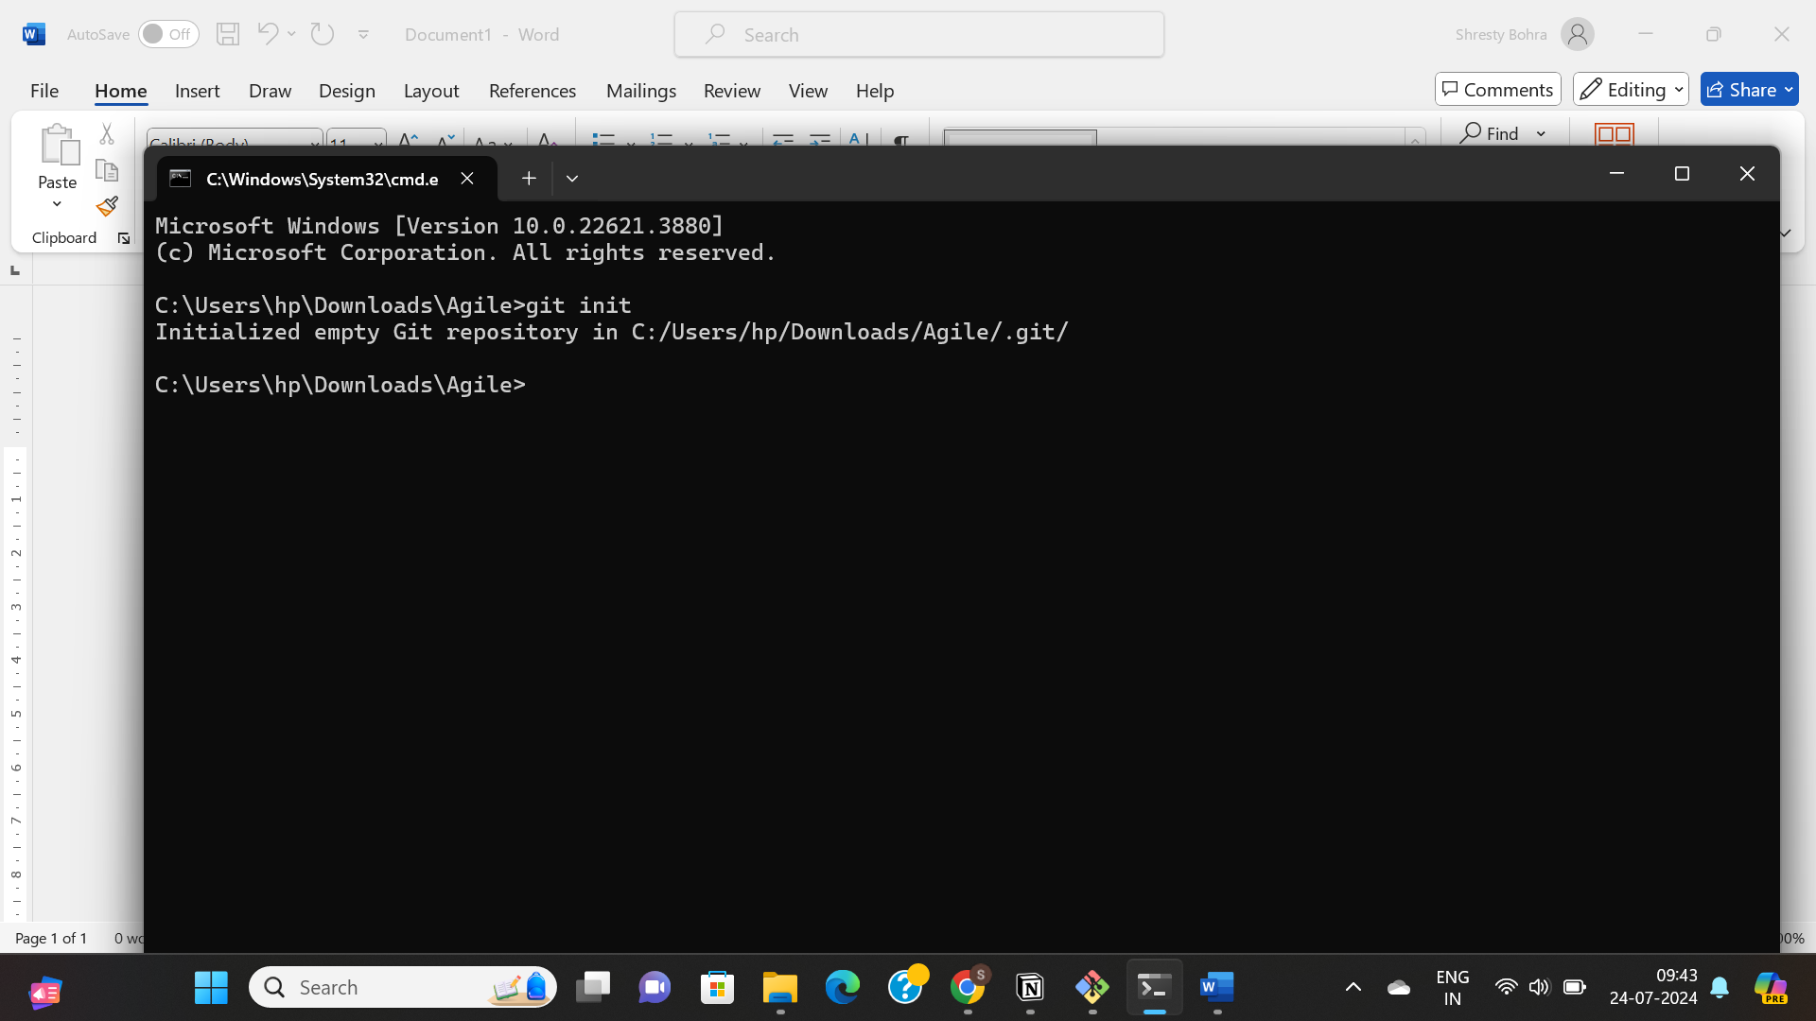

**Clone a Repository – git clone**Creates a copy of an existing repository.

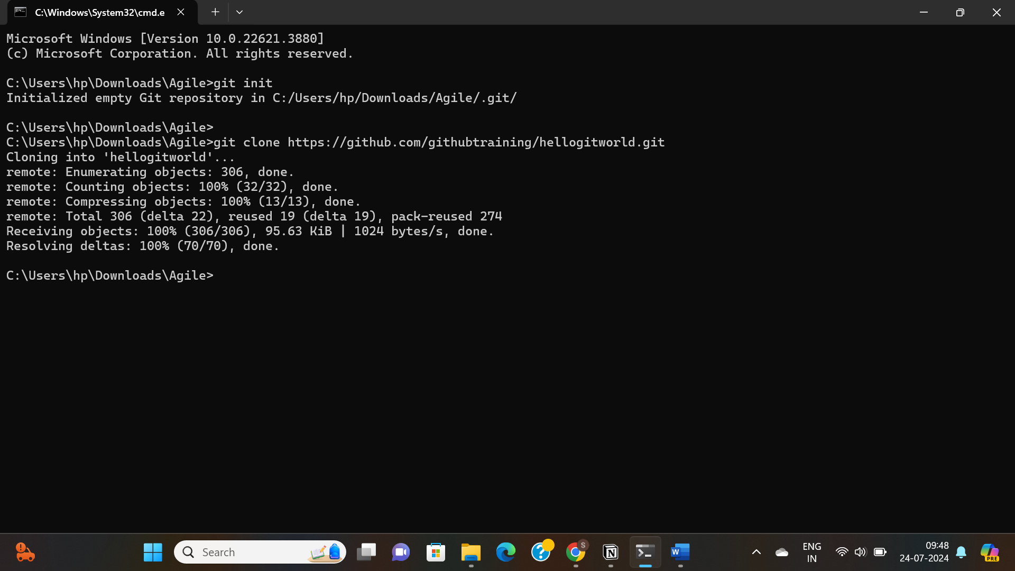

To check the status of your repository:

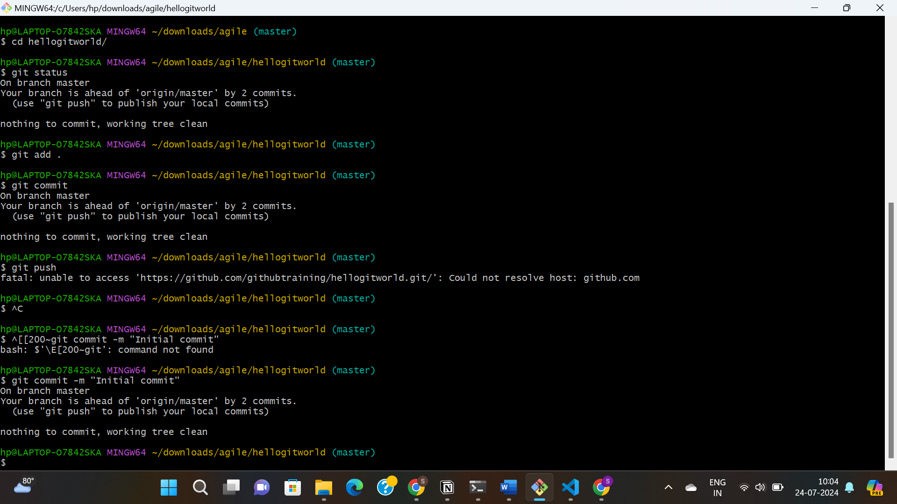



Git commit -m "Initial commit"



Uploads local repository content to a remote repository.

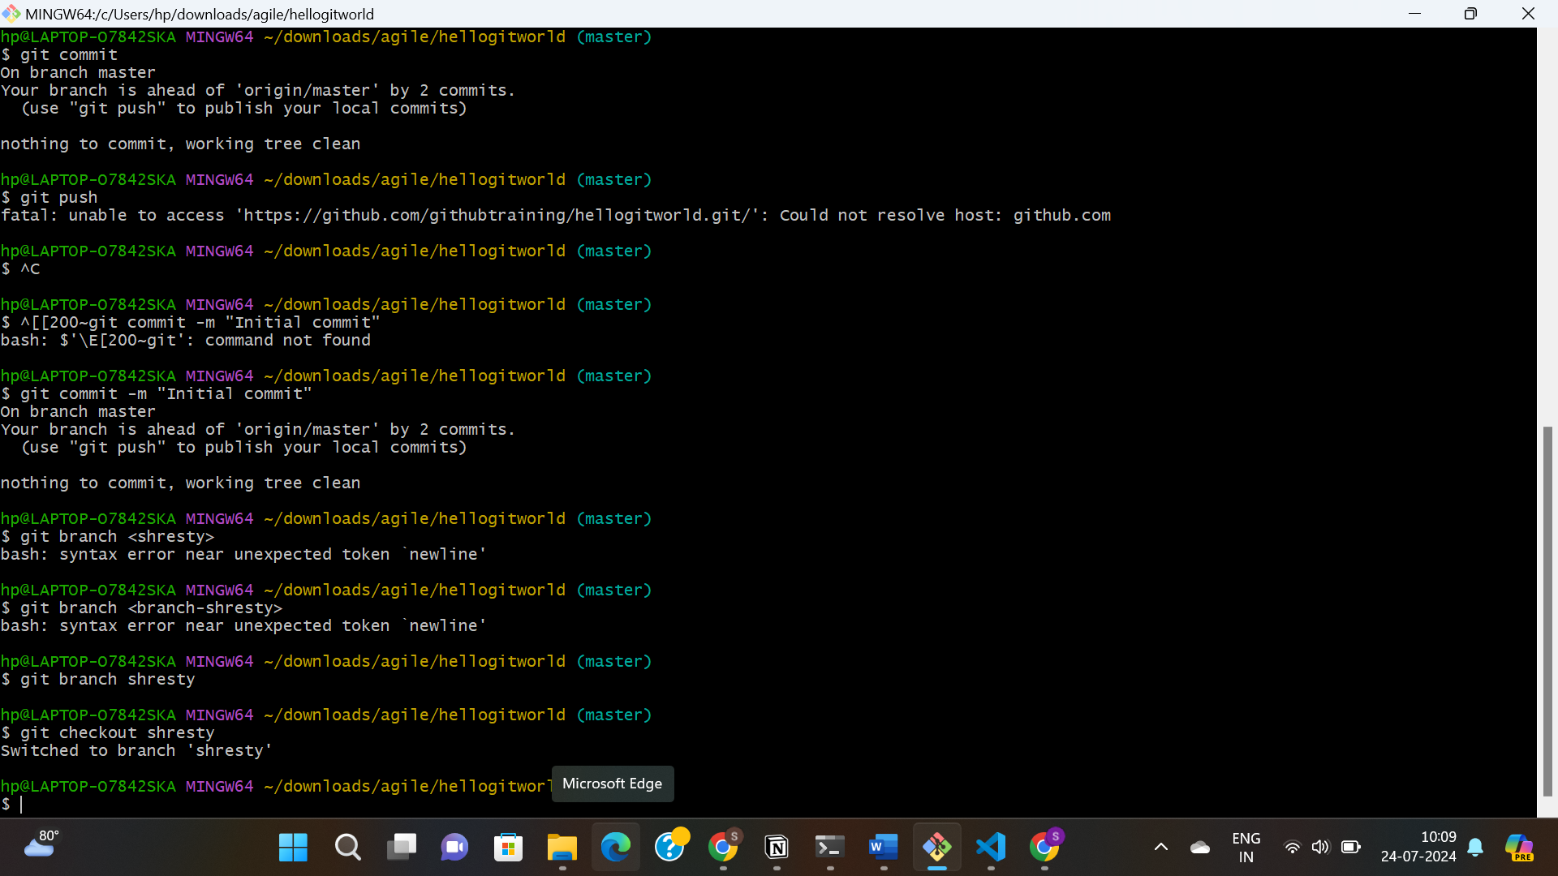

Uploads local repository content to a remote repository.



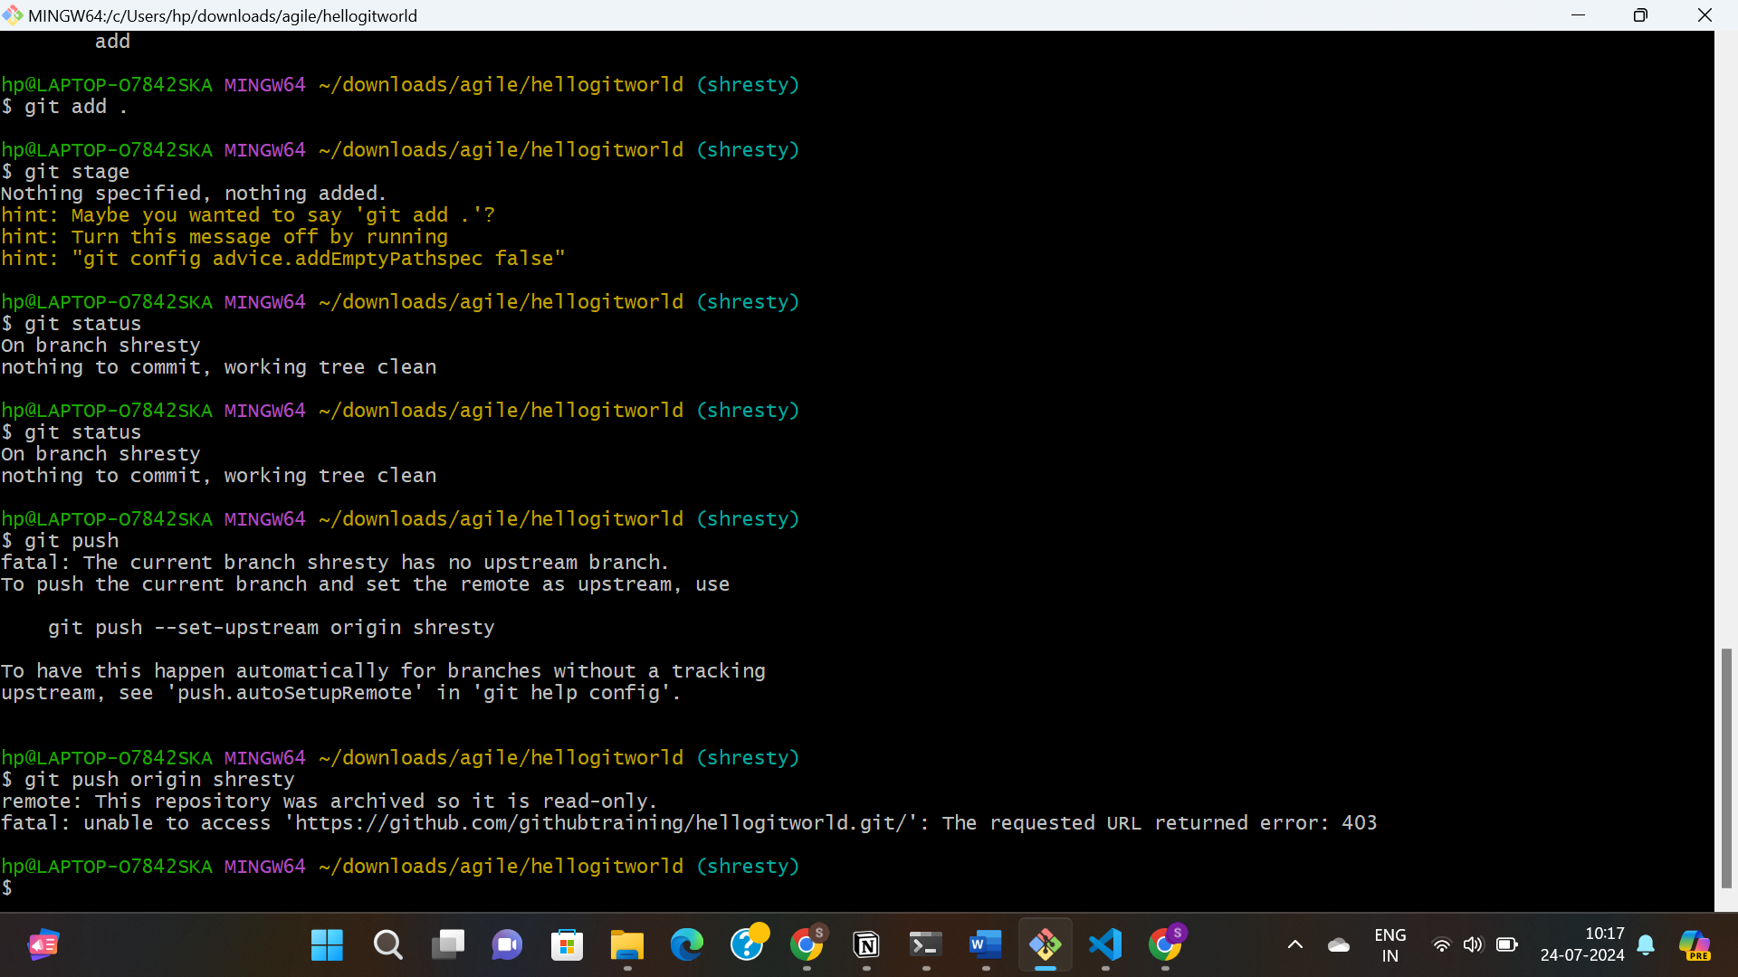

Running all the commands again to another repository

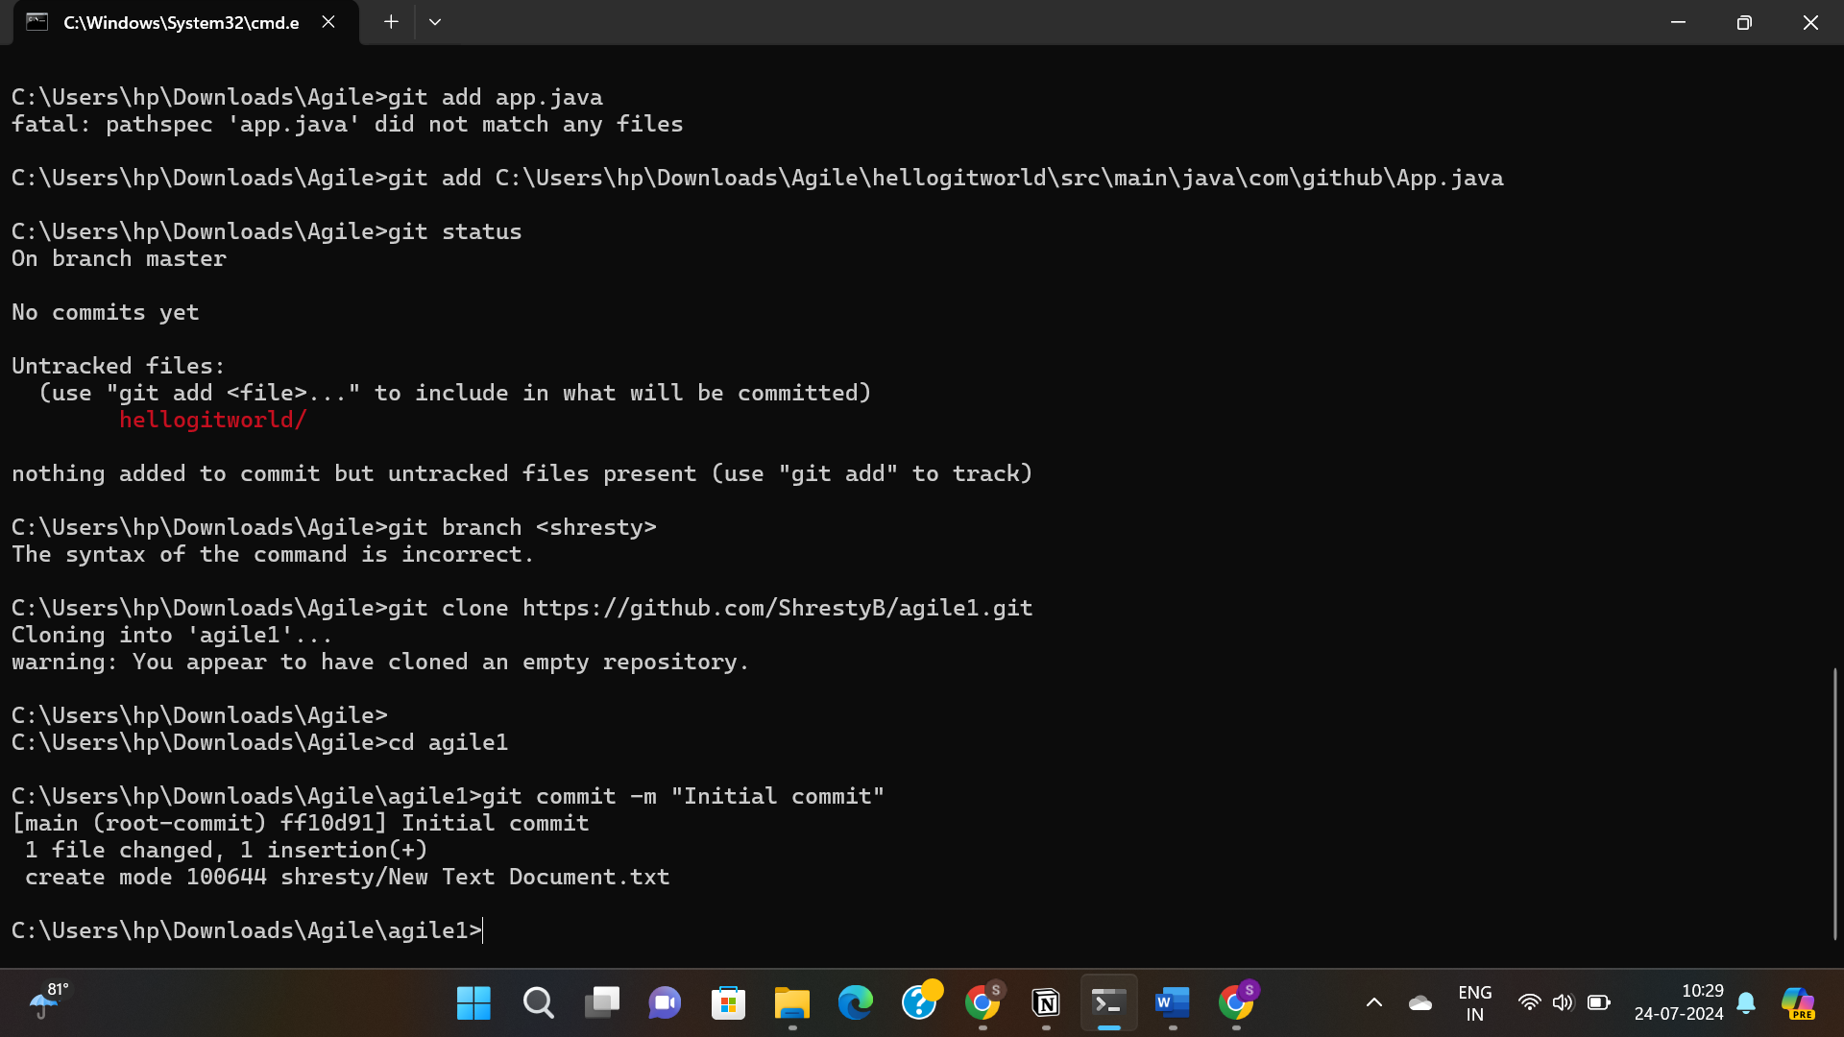

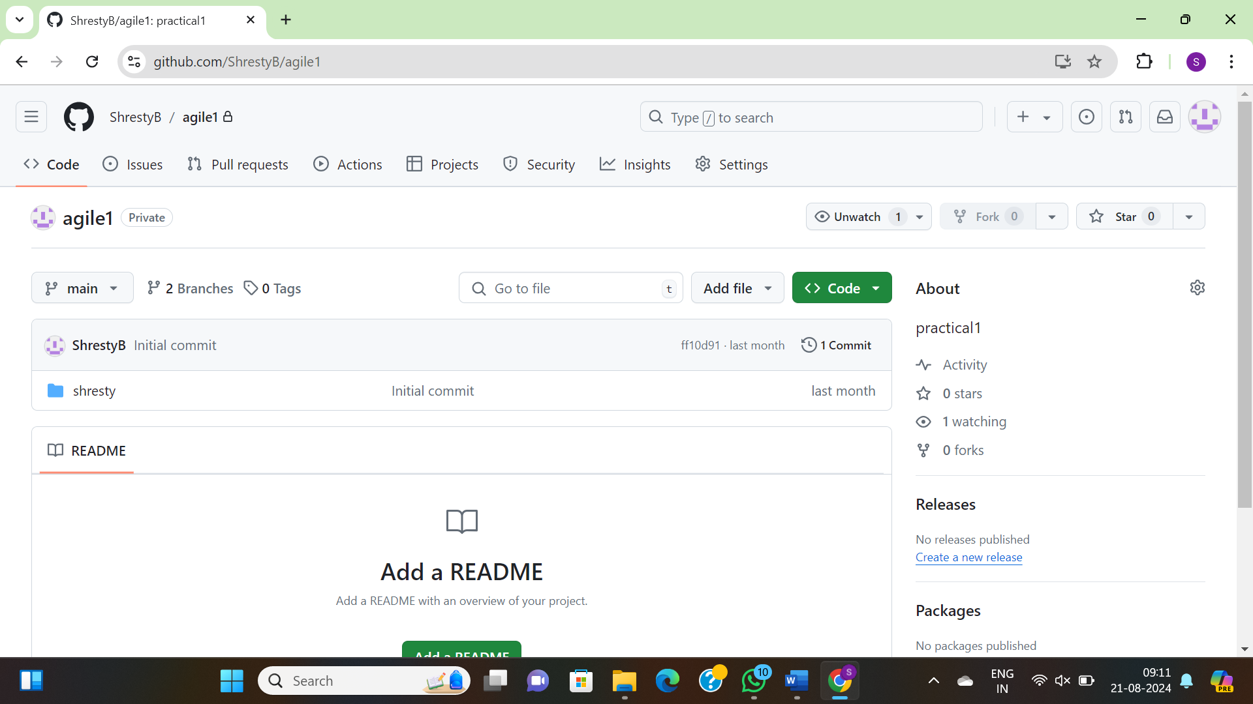

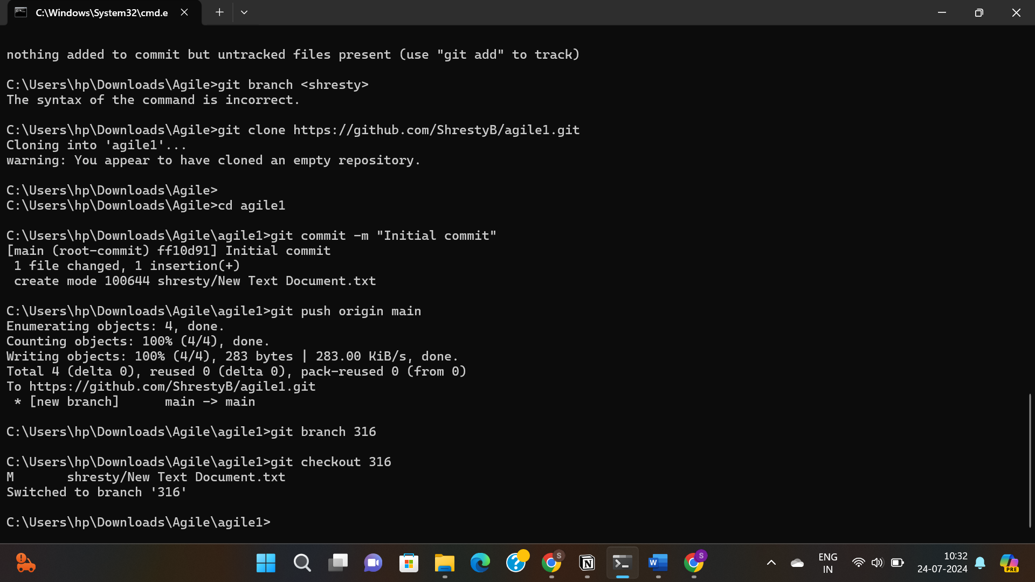

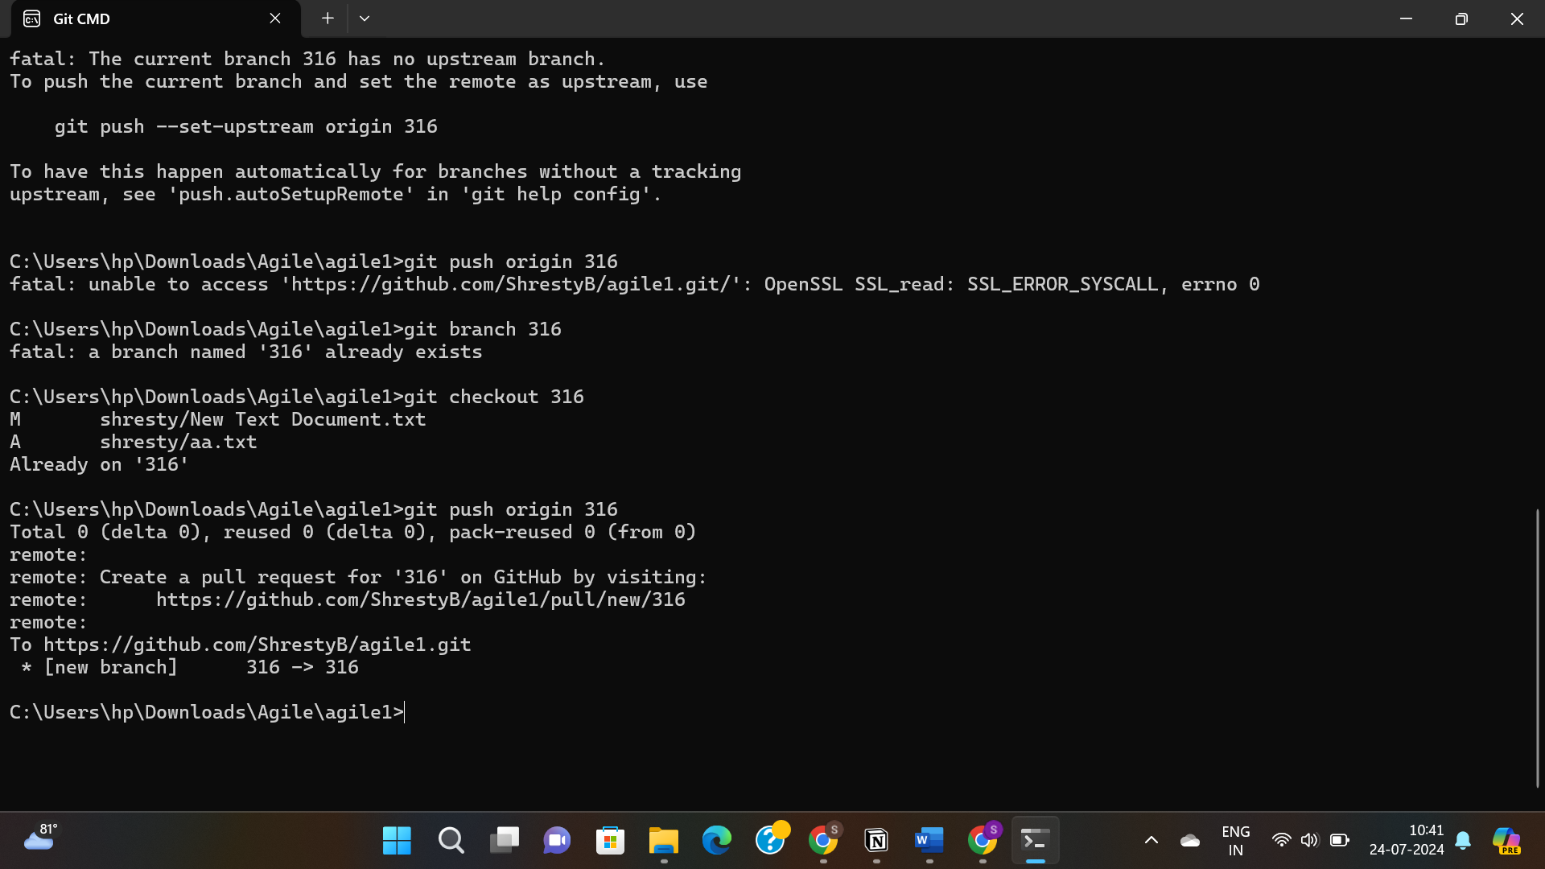

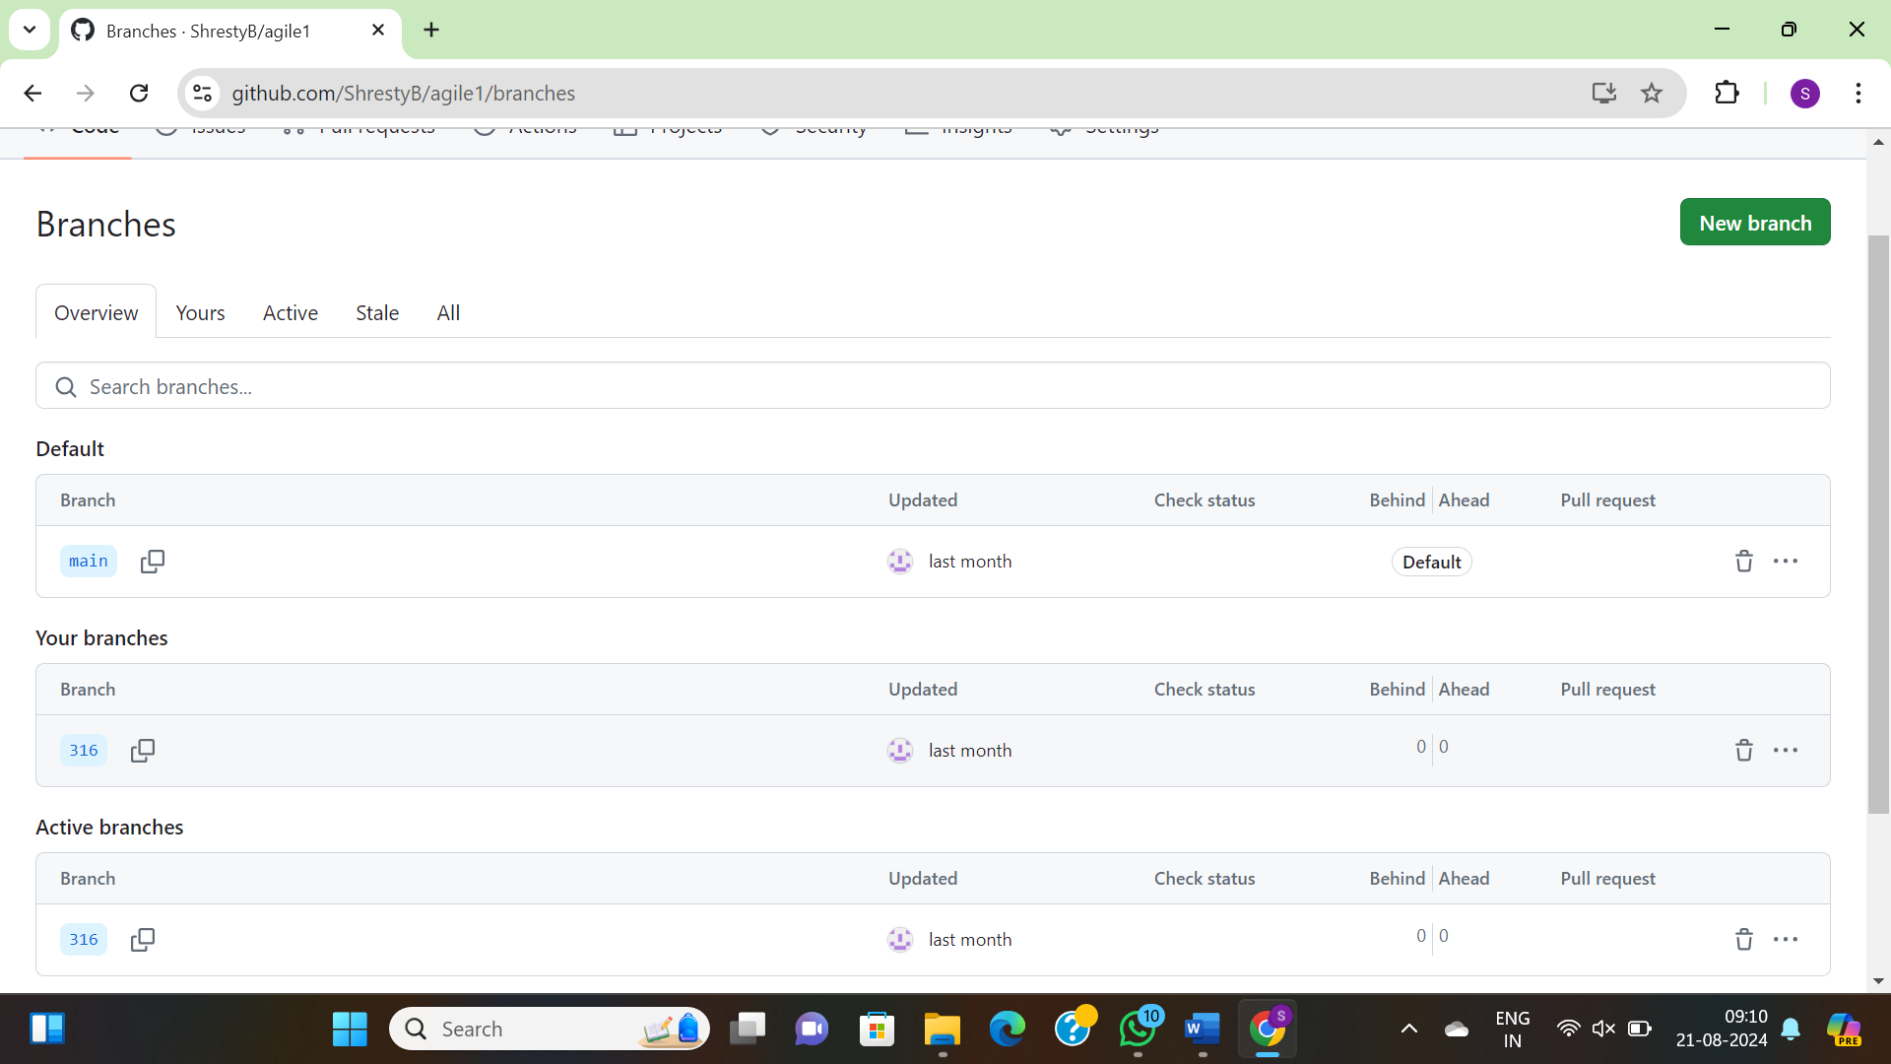

LAB2

We are going to create a simple CloudFormation template and provision a new S3 bucket.

**YAML**-based templates use less punctuation and should be substantially easier to write and to read. They also allow the use of comments. That is why we will go with YAML.

Parameters:

paramTagValue: # declare paramTagValue as a parameter

Description: Value of tag for EC2 instance

Type: String

paramKeyName: # declare paramKeyName as a parameter

Description: Name of an existing EC2 KeyPair to enable SSH access into the server

Type: 'AWS::EC2::KeyPair::KeyName'

Resources:

myEc2Instance: # Logical ID

Type: 'AWS::EC2::Instance'

Properties:

InstanceType: t2.micro

ImageId: ami-5b41123e

Tags:

- Key: Agilelab

Value: !Ref paramTagValue # ref to Parameters

KeyName: !Ref paramKeyName # ref to Parameters

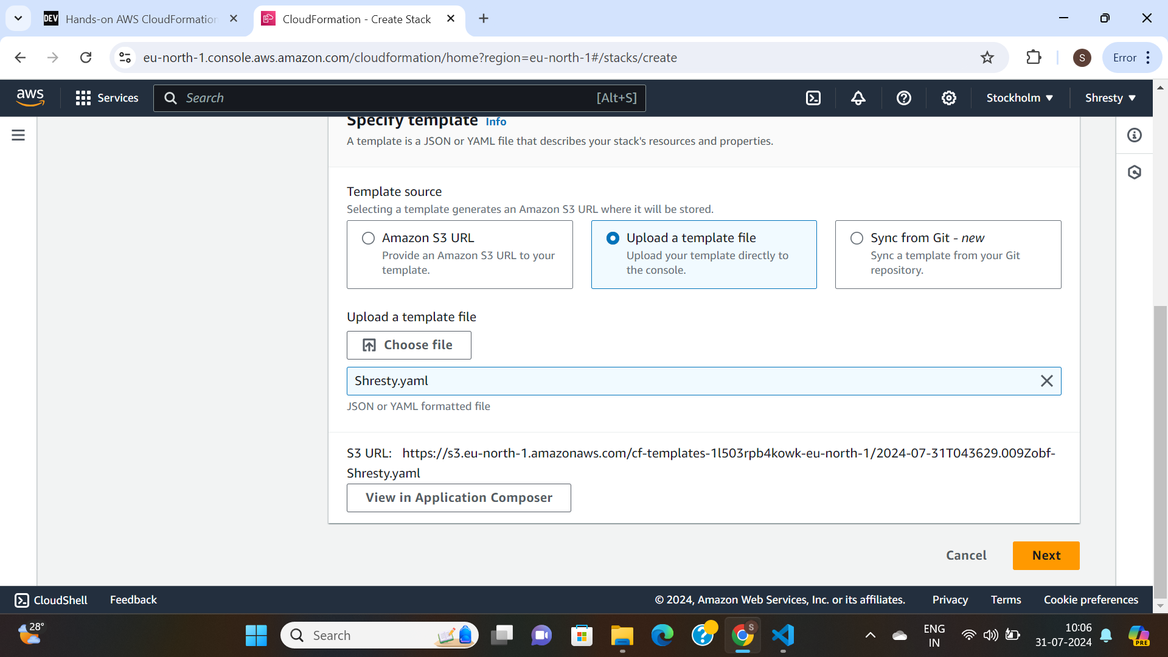

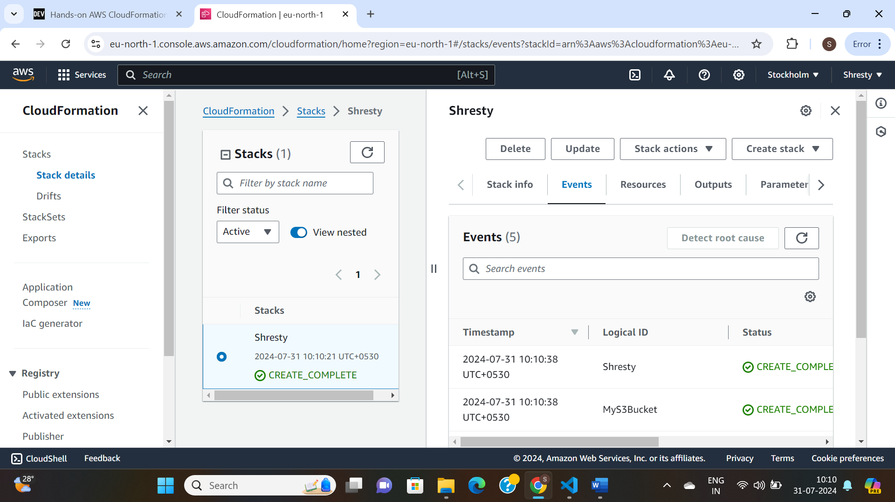

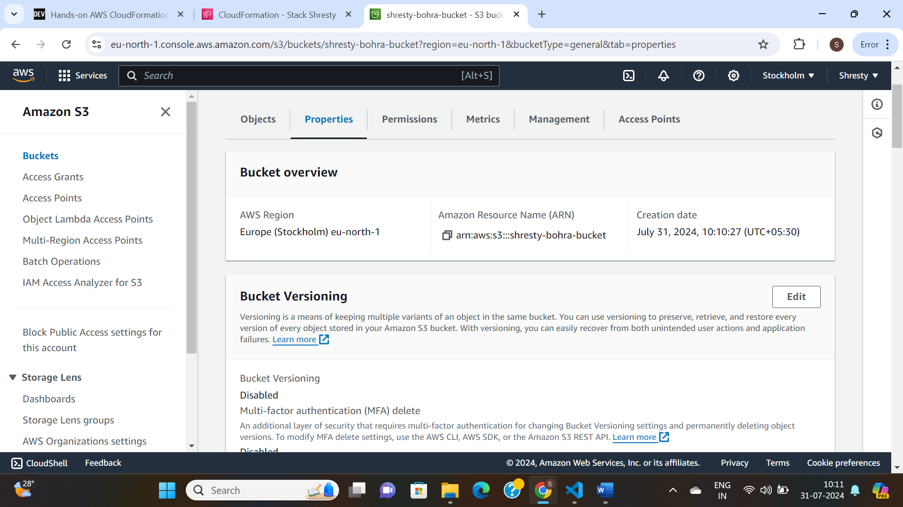

Launched an instance:

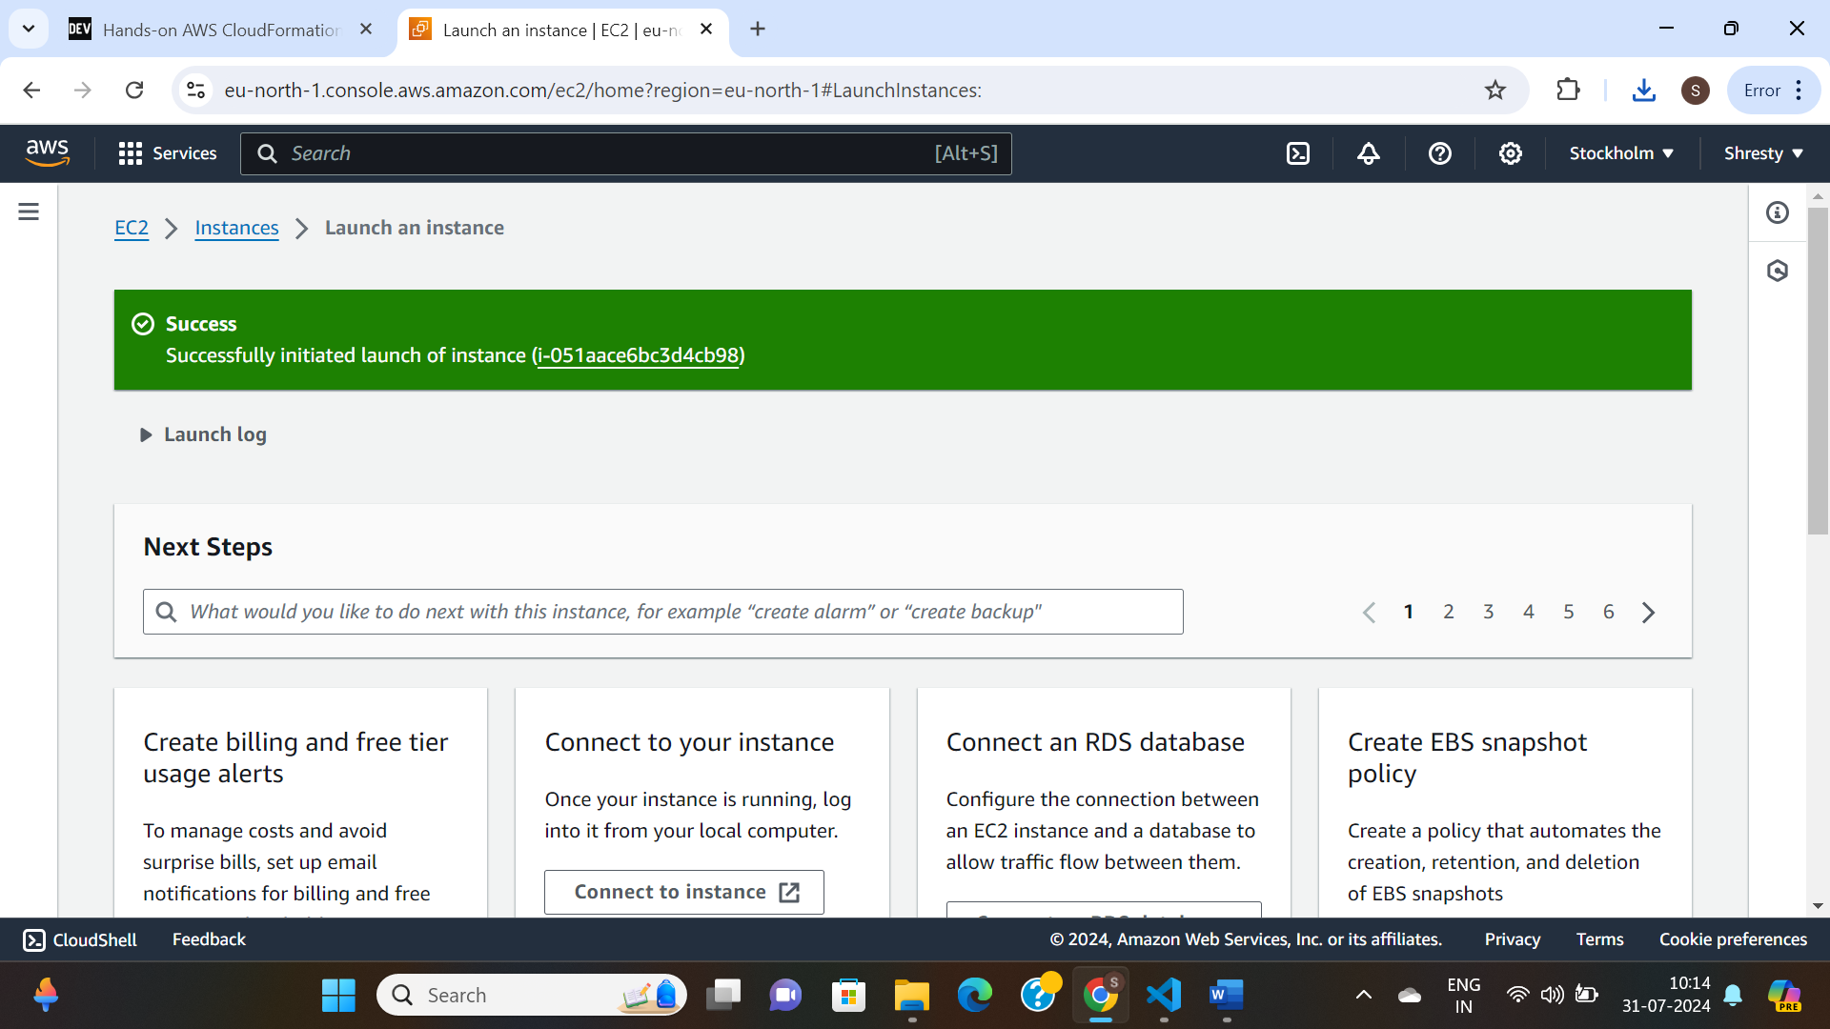

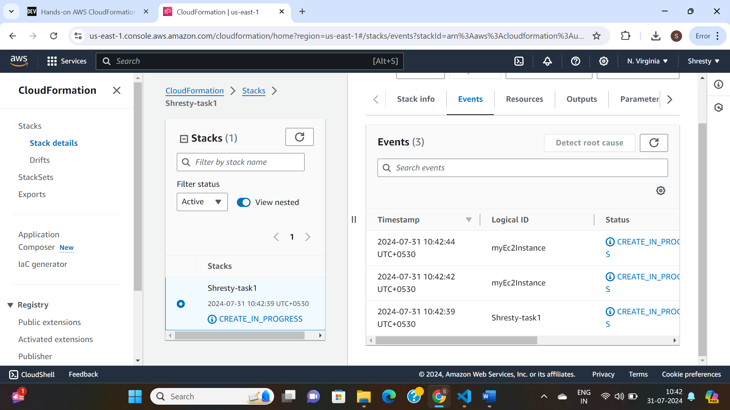

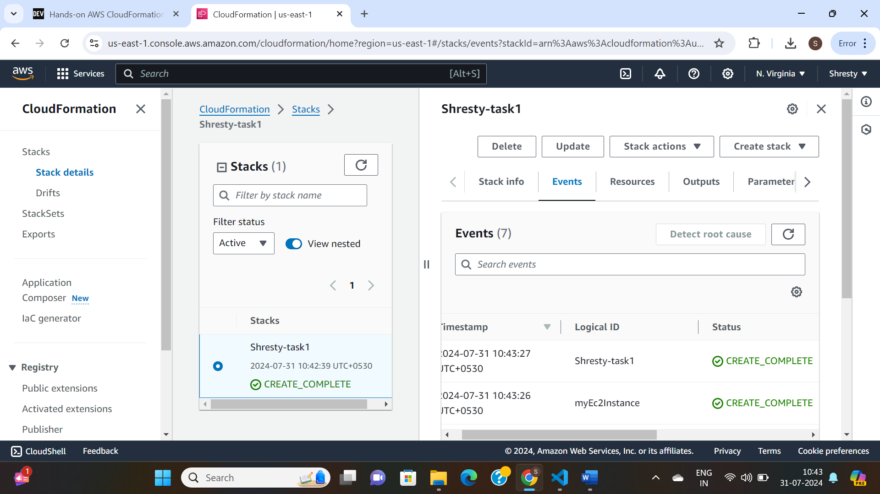

**Task 1: Using Cloudformation temmplate yaml, Create a EC2 Instance and output Public IP and Private IPs.**

AWSTemplateFormatVersion: '2010-09-09'

Description: Create an EC2 instance and output Public and Private IP addresses.

Resources:

MyEC2Instance:

Type: 'AWS::EC2::Instance'

Properties:

InstanceType: t2.micro

ImageId: ami-5b41123e # Replace with the desired AMI ID

#KeyName: your-key-pair # Replace with your key pair name

Tags:

- Key: Agilelab

Value: MyEC2Instance

Outputs:

PublicIP:

Description: 'Public IP address of the EC2 instance'

Value: !GetAtt MyEC2Instance.PublicIp

PrivateIP:

Description: 'Private IP address of the EC2 instance'

Value: !GetAtt MyEC2Instance.PrivateIp

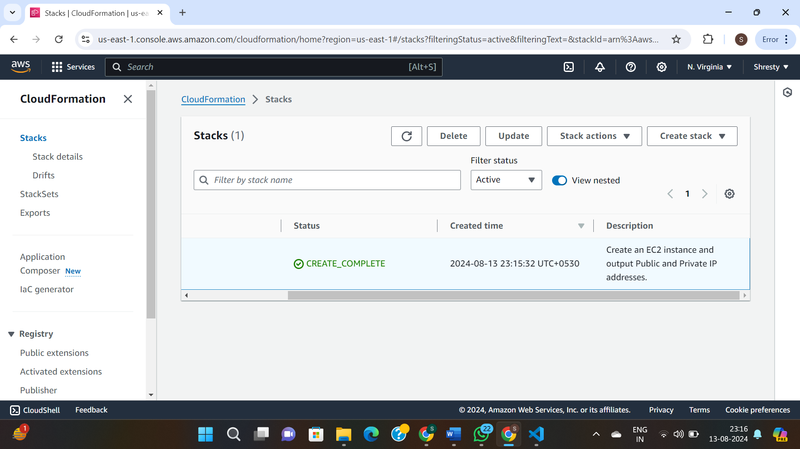

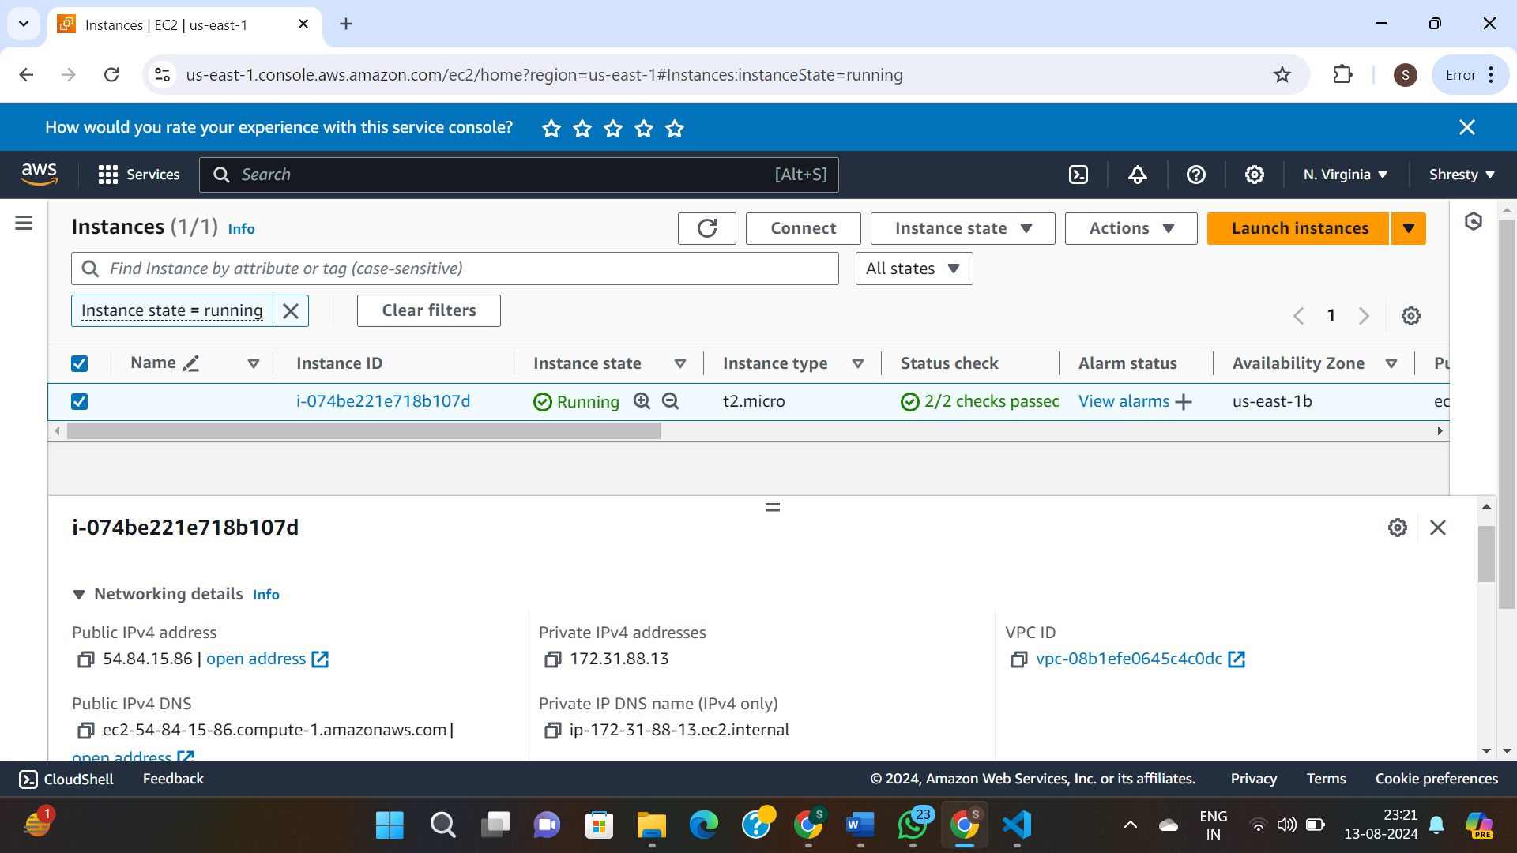

**Task 2:Using Cloudformation temmplate yaml, Create a EC2 Instance/ElasticIP/SecurityGroup and output Public IP and Private IPs.**

AWSTemplateFormatVersion: '2010-09-09'

Description: Create an EC2 instance, Elastic IP, and Security Group, and output Public and Private IP addresses.

Resources:

MySecurityGroup:

Type: 'AWS::EC2::SecurityGroup'

Properties:

GroupDescription: 'Allow SSH and HTTP access'

SecurityGroupIngress:

- IpProtocol: tcp

FromPort: '22'

ToPort: '22'

CidrIp: '0.0.0.0/0'

- IpProtocol: tcp

FromPort: '80'

ToPort: '80'

CidrIp: '0.0.0.0/0'

MyEC2Instance:

Type: 'AWS::EC2::Instance'

Properties:

InstanceType: t2.micro

ImageId: ami-5b41123e # Replace with the desired AMI ID

#KeyName: your-key-pair # Replace with your key pair name

SecurityGroups:

- !Ref MySecurityGroup

Tags:

- Key: Name

Value: MyEC2Instance

MyElasticIP:

Type: 'AWS::EC2::EIP'

EIPAssociation:

Type: 'AWS::EC2::EIPAssociation'

Properties:

InstanceId: !Ref MyEC2Instance

EIP: !Ref MyElasticIP

Outputs:

PublicIP:

Description: 'Public IP address of the EC2 instance'

Value: !Ref MyElasticIP

PrivateIP:

Description: 'Private IP address of the EC2 instance'

Value: !GetAtt MyEC2Instance.PrivateIp

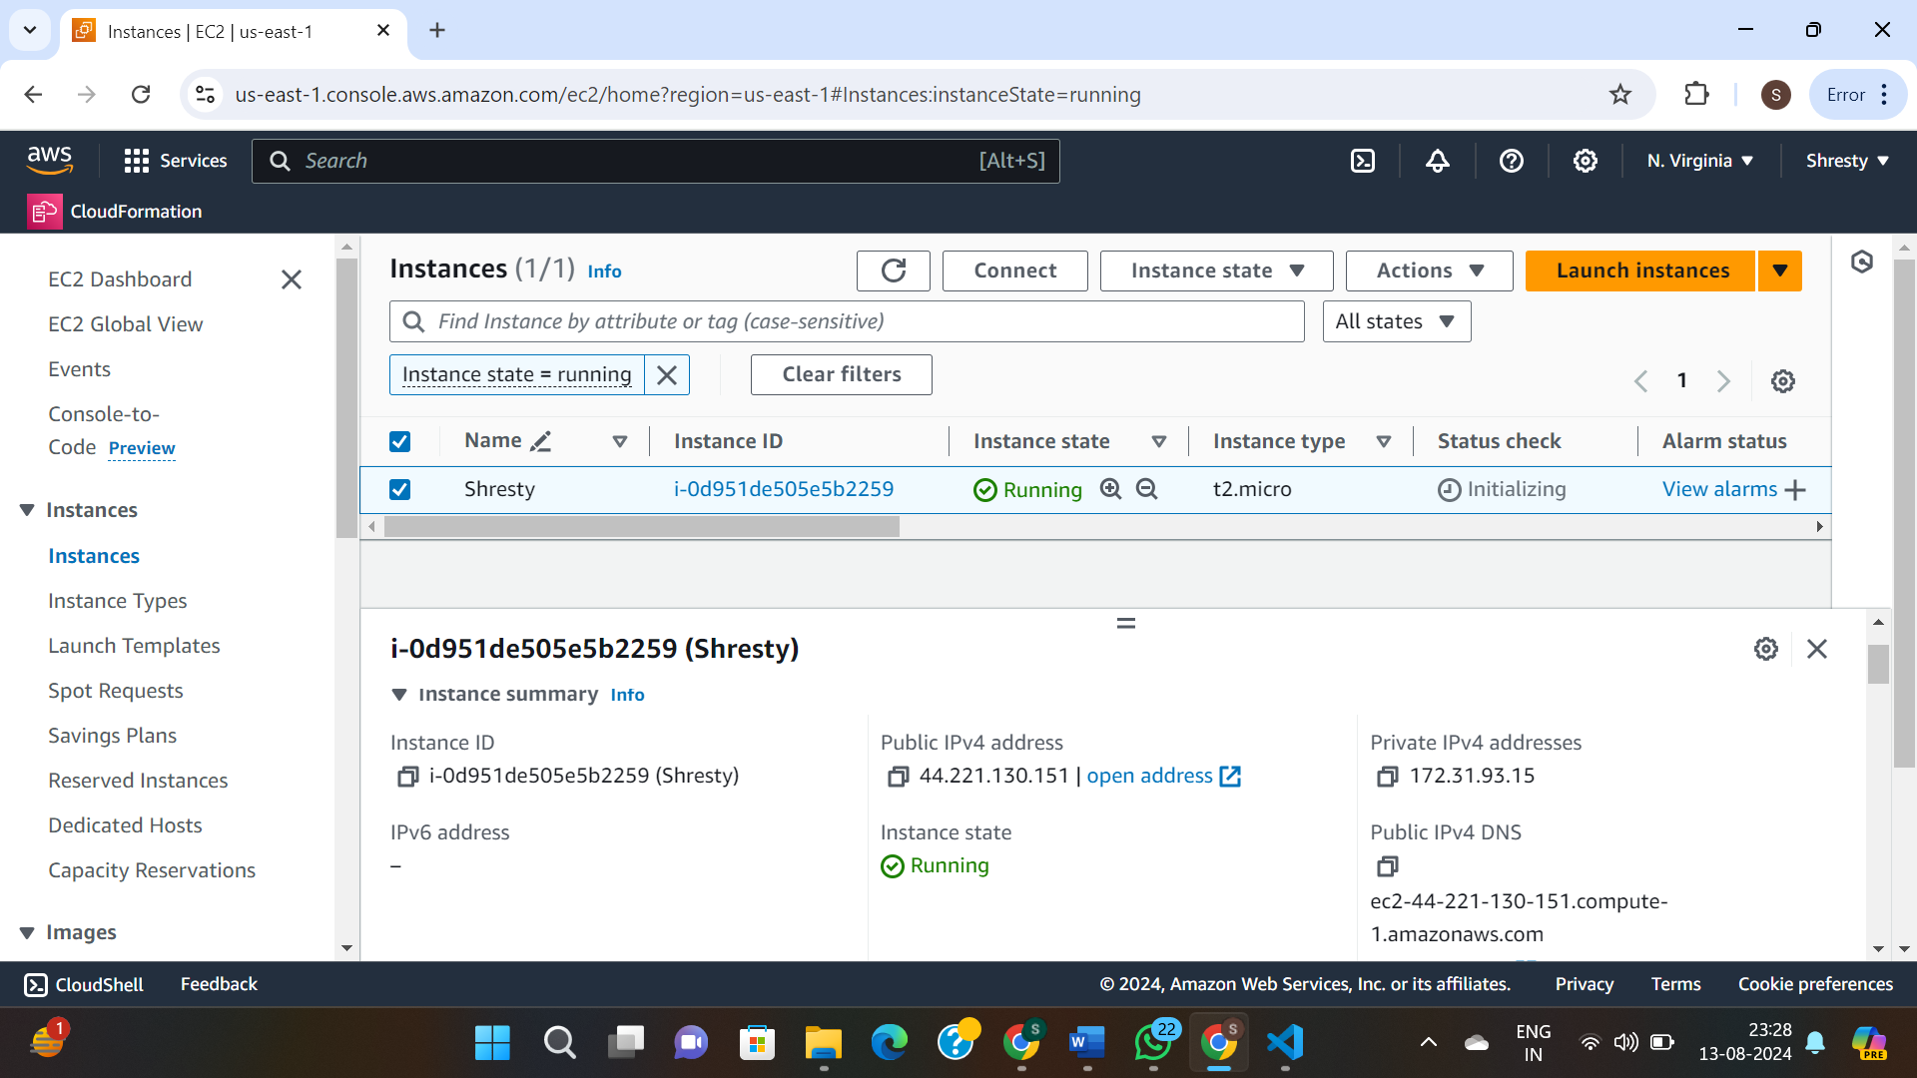

**Task 3:Using Cloudformation temmplate yaml, Create a EC2 Instance/ElasticIP/SecurityGroup/EBS and output Public IP and Private IPs.**

AWSTemplateFormatVersion: '2010-09-09'

Description: Create an EC2 instance, Elastic IP, Security Group, and EBS volume, and output Public and Private IP addresses.

Resources:

MySecurityGroup:

Type: 'AWS::EC2::SecurityGroup'

Properties:

GroupDescription: 'Allow SSH and HTTP access'

SecurityGroupIngress:

- IpProtocol: tcp

FromPort: '22'

ToPort: '22'

CidrIp: '0.0.0.0/0'

- IpProtocol: tcp

FromPort: '80'

ToPort: '80'

CidrIp: '0.0.0.0/0'

MyEC2Instance:

Type: 'AWS::EC2::Instance'

Properties:

InstanceType: t2.micro

ImageId: ami-5b41123e # Replace with the desired AMI ID

#KeyName: your-key-pair # Replace with your key pair name

SecurityGroups:

- !Ref MySecurityGroup

Tags:

- Key: Name

Value: MyEC2Instance

MyElasticIP:

Type: 'AWS::EC2::EIP'

EIPAssociation:

Type: 'AWS::EC2::EIPAssociation'

Properties:

InstanceId: !Ref MyEC2Instance

EIP: !Ref MyElasticIP

MyEBSVolume:

Type: 'AWS::EC2::Volume'

Properties:

AvailabilityZone: !GetAtt MyEC2Instance.AvailabilityZone

Size: 8 # Size in GB

VolumeAttachment:

Type: 'AWS::EC2::VolumeAttachment'

Properties:

InstanceId: !Ref MyEC2Instance

VolumeId: !Ref MyEBSVolume

Device: /dev/sdh

Outputs:

PublicIP:

Description: 'Public IP address of the EC2 instance'

Value: !Ref MyElasticIP

PrivateIP:

Description: 'Private IP address of the EC2 instance'

Value: !GetAtt MyEC2Instance.PrivateIp

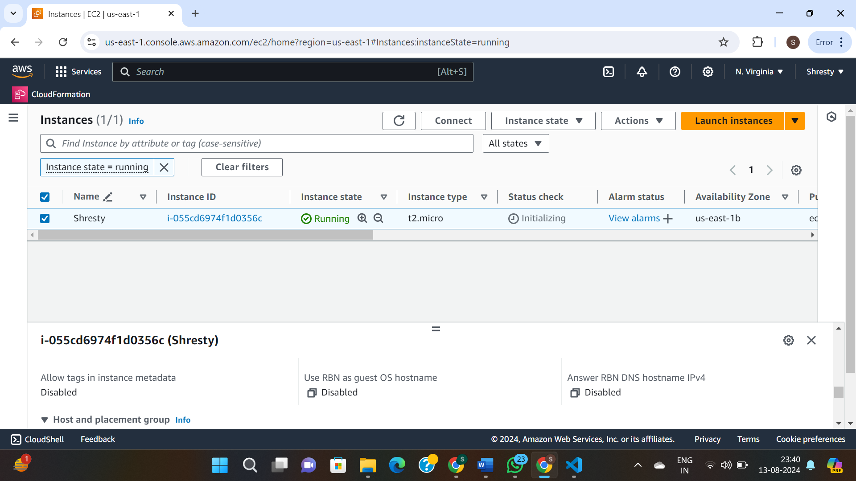

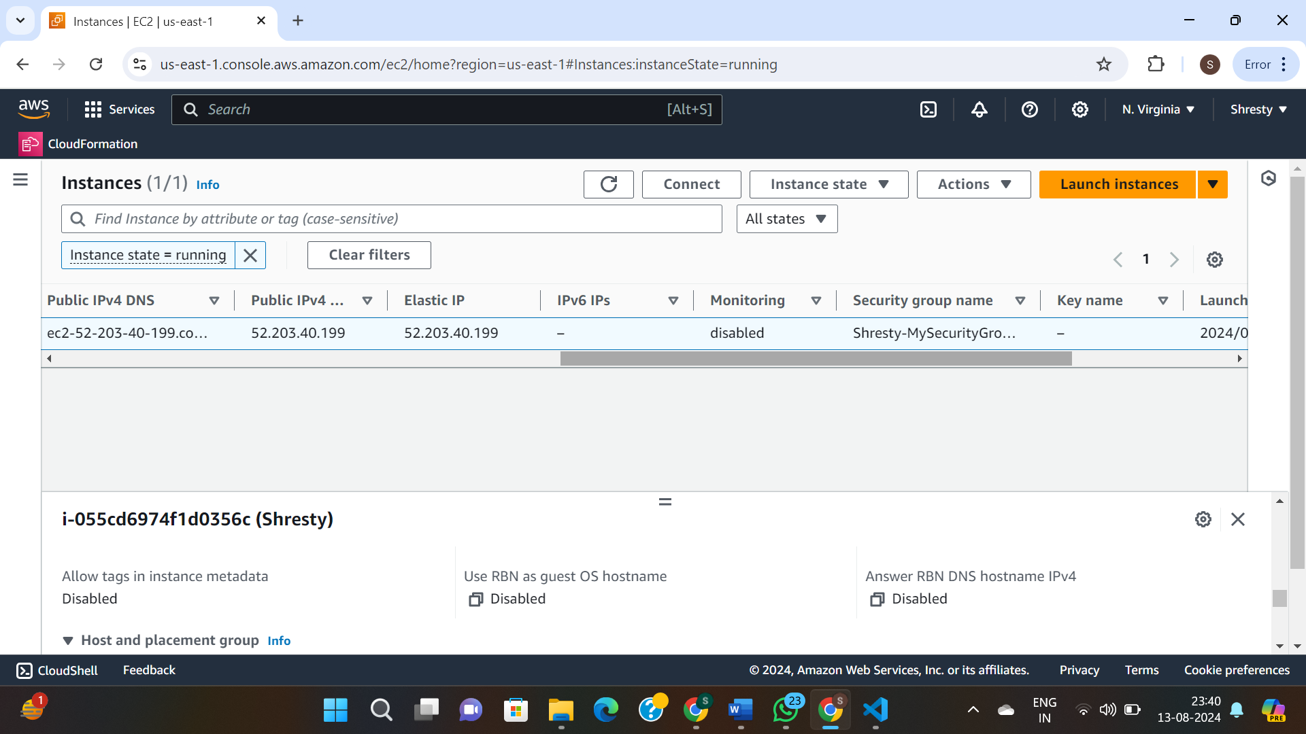

**Task 4: Description: CloudFormation Template to create an EC2 Instance with an Elastic IP, Security Group, EBS volume, and a web server setup. Outputs Public and Private IP addresses.**

Description: CloudFormation Template to create an EC2 Instance with an Elastic IP, Security Group, EBS volume, and a web server setup. Outputs Public and Private IP addresses.

Resources:

MyEC2Instance:

Type: 'AWS::EC2::Instance'

Properties:

InstanceType: 't2.micro'

ImageId: 'ami-5b41123e' # Replace with the appropriate AMI ID for your region

SecurityGroups:

- !Ref MySecurityGroup

UserData:

Fn::Base64: !Sub |

#!/bin/bash

yum update -y

yum install -y httpd

systemctl start httpd

systemctl enable httpd

echo "<h1>Welcome to your Web Server!</h1>" > /var/www/html/index.html

Tags:

- Key: Nisargi

Value: MyEC2Instance

MyElasticIP:

Type: 'AWS::EC2::EIP'

Properties:

Domain: vpc

InstanceId: !Ref MyEC2Instance

MySecurityGroup:

Type: 'AWS::EC2::SecurityGroup'

Properties:

GroupDescription: Allow SSH and HTTP access

SecurityGroupIngress:

- IpProtocol: tcp

FromPort: '22'

ToPort: '22'

CidrIp: '0.0.0.0/0'

- IpProtocol: tcp

FromPort: '80'

ToPort: '80'

CidrIp: '0.0.0.0/0'

MyEBSVolume:

Type: 'AWS::EC2::Volume'

Properties:

AvailabilityZone: !GetAtt MyEC2Instance.AvailabilityZone

Size: 10 # Size of the EBS volume in GB

VolumeType: gp2

DeletionPolicy: Retain

MyVolumeAttachment:

Type: 'AWS::EC2::VolumeAttachment'

Properties:

InstanceId: !Ref MyEC2Instance

VolumeId: !Ref MyEBSVolume

Device: '/dev/sdh'

Outputs:

InstancePublicIP:

Description: The Public IP address (Elastic IP) of the EC2 instance

Value: !Ref MyElasticIP

InstancePrivateIP:

Description: The Private IP address of the EC2 instance

Value: !GetAtt

- MyEC2Instance

- PrivateIp

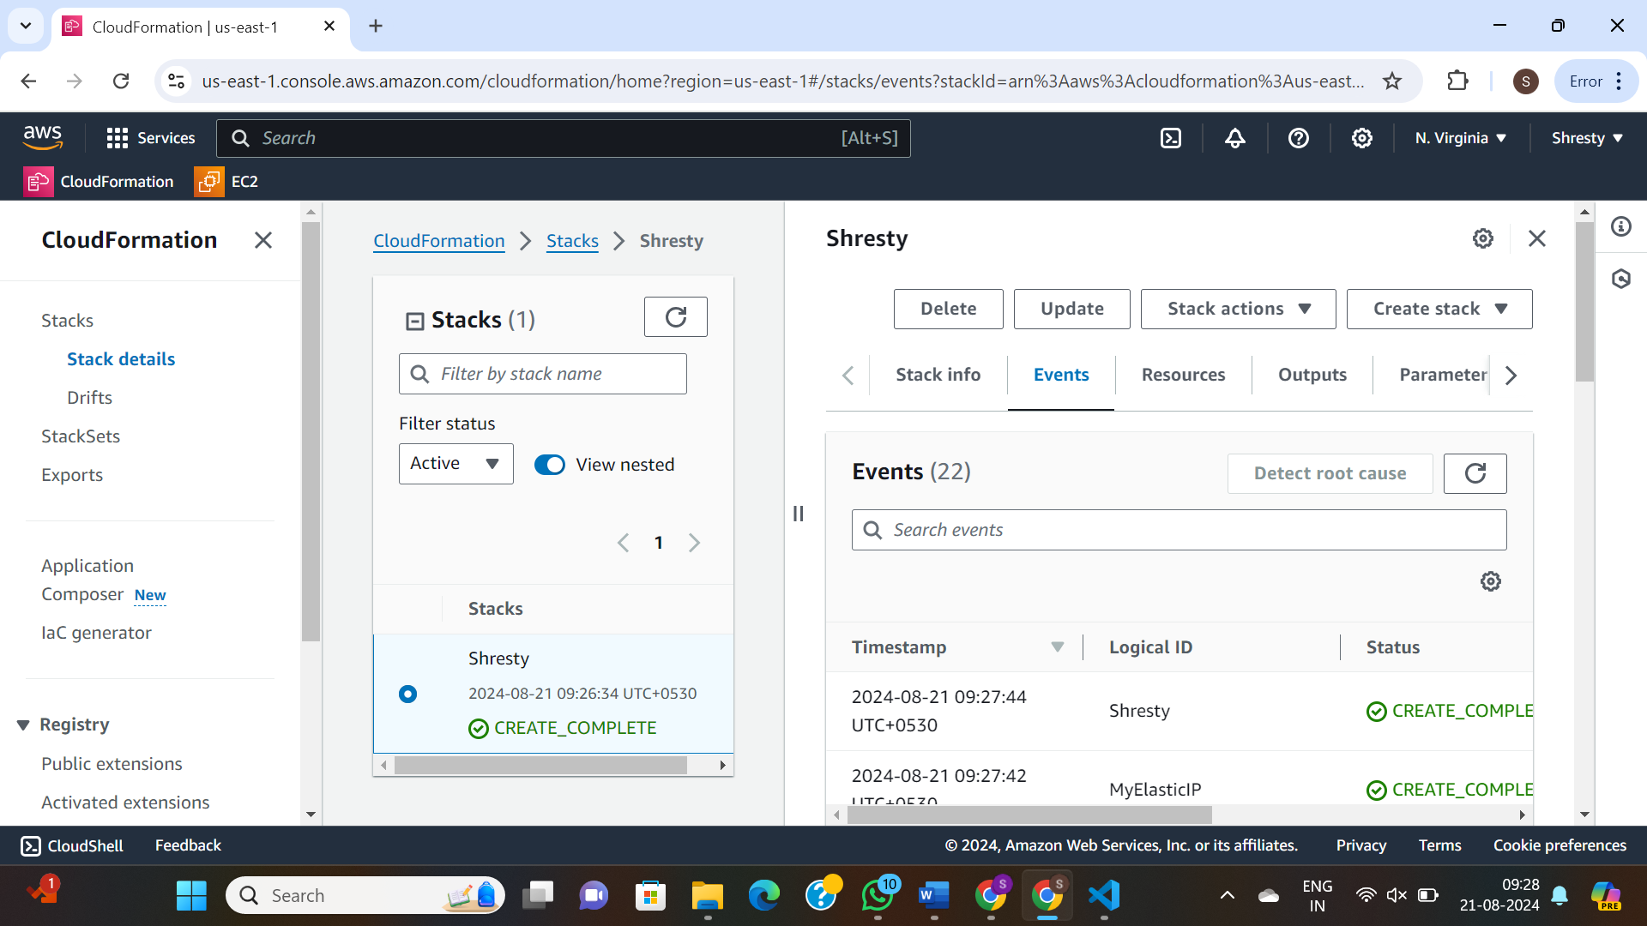

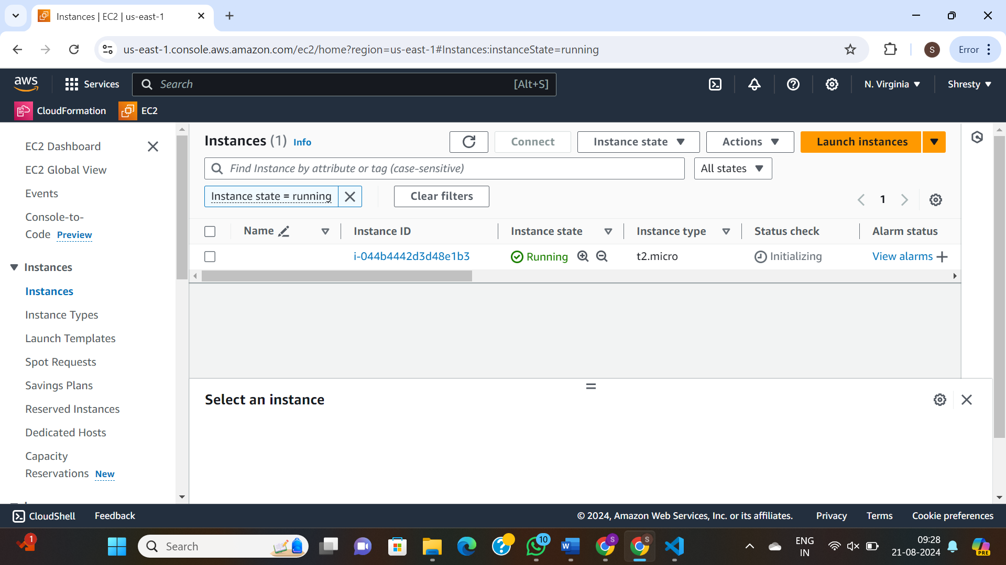

**Task 5:Description: CloudFormation Template to create an EC2 Instance with Parameters, Mappings, and Outputs for InstanceId, AvailabilityZone, PublicDnsName, and PublicIp.**

Description: CloudFormation Template to create an EC2 Instance with Parameters, Mappings, and Outputs for InstanceId, AvailabilityZone, PublicDnsName, and PublicIp.

Parameters:

InstanceType:

Description: EC2 instance type

Type: String

Default: t2.micro

AllowedValues:

- t2.micro

- t2.small

- t2.medium

ConstraintDescription: must be a valid EC2 instance type.

AmiId:

Description: AMI ID for the EC2 instance

Type: String

Default: ami-5b41123e # Replace with an appropriate default AMI ID for your region

Mappings:

RegionMap:

us-east-1:

"AMI": ami-5b41123e

us-west-2:

"AMI": ami-094be4c7f1e506a7a

eu-west-1:

"AMI": ami-0710bb577045071ff

Resources:

MyEC2Instance:

Type: 'AWS::EC2::Instance'

Properties:

InstanceType: !Ref InstanceType

ImageId: !FindInMap

- RegionMap

- !Ref "AWS::Region"

- AMI

SecurityGroups:

- !Ref MySecurityGroup

Tags:

- Key: Name

Value: MyEC2Instance

MySecurityGroup:

Type: 'AWS::EC2::SecurityGroup'

Properties:

GroupDescription: Allow SSH and HTTP access

SecurityGroupIngress:

- IpProtocol: tcp

FromPort: '22'

ToPort: '22'

CidrIp: '0.0.0.0/0'

- IpProtocol: tcp

FromPort: '80'

ToPort: '80'

CidrIp: '0.0.0.0/0'

Outputs:

InstanceId:

Description: The Instance ID of the EC2 instance

Value: !Ref MyEC2Instance

AvailabilityZone:

Description: The Availability Zone where the EC2 instance is launched

Value: !GetAtt MyEC2Instance.AvailabilityZone

PublicDnsName:

Description: The Public DNS Name of the EC2 instance

Value: !GetAtt MyEC2Instance.PublicDnsName

PublicIp:

Description: The Public IP address of the EC2 instance

Value: !GetAtt MyEC2Instance.PublicIp

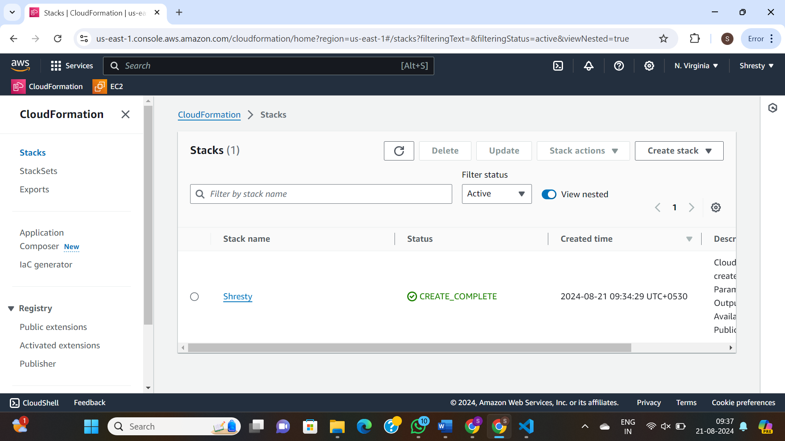

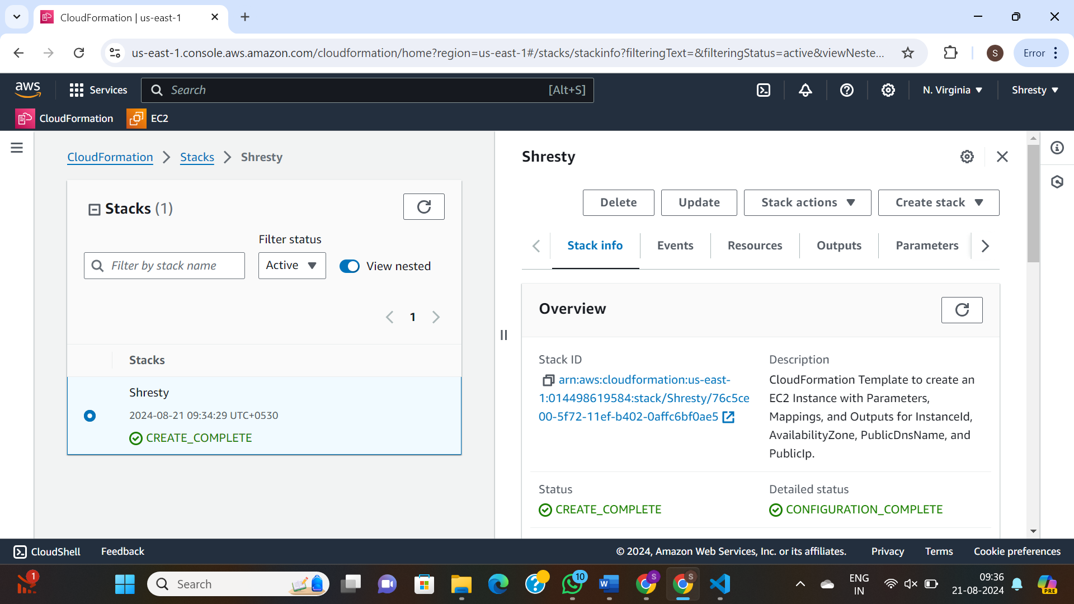

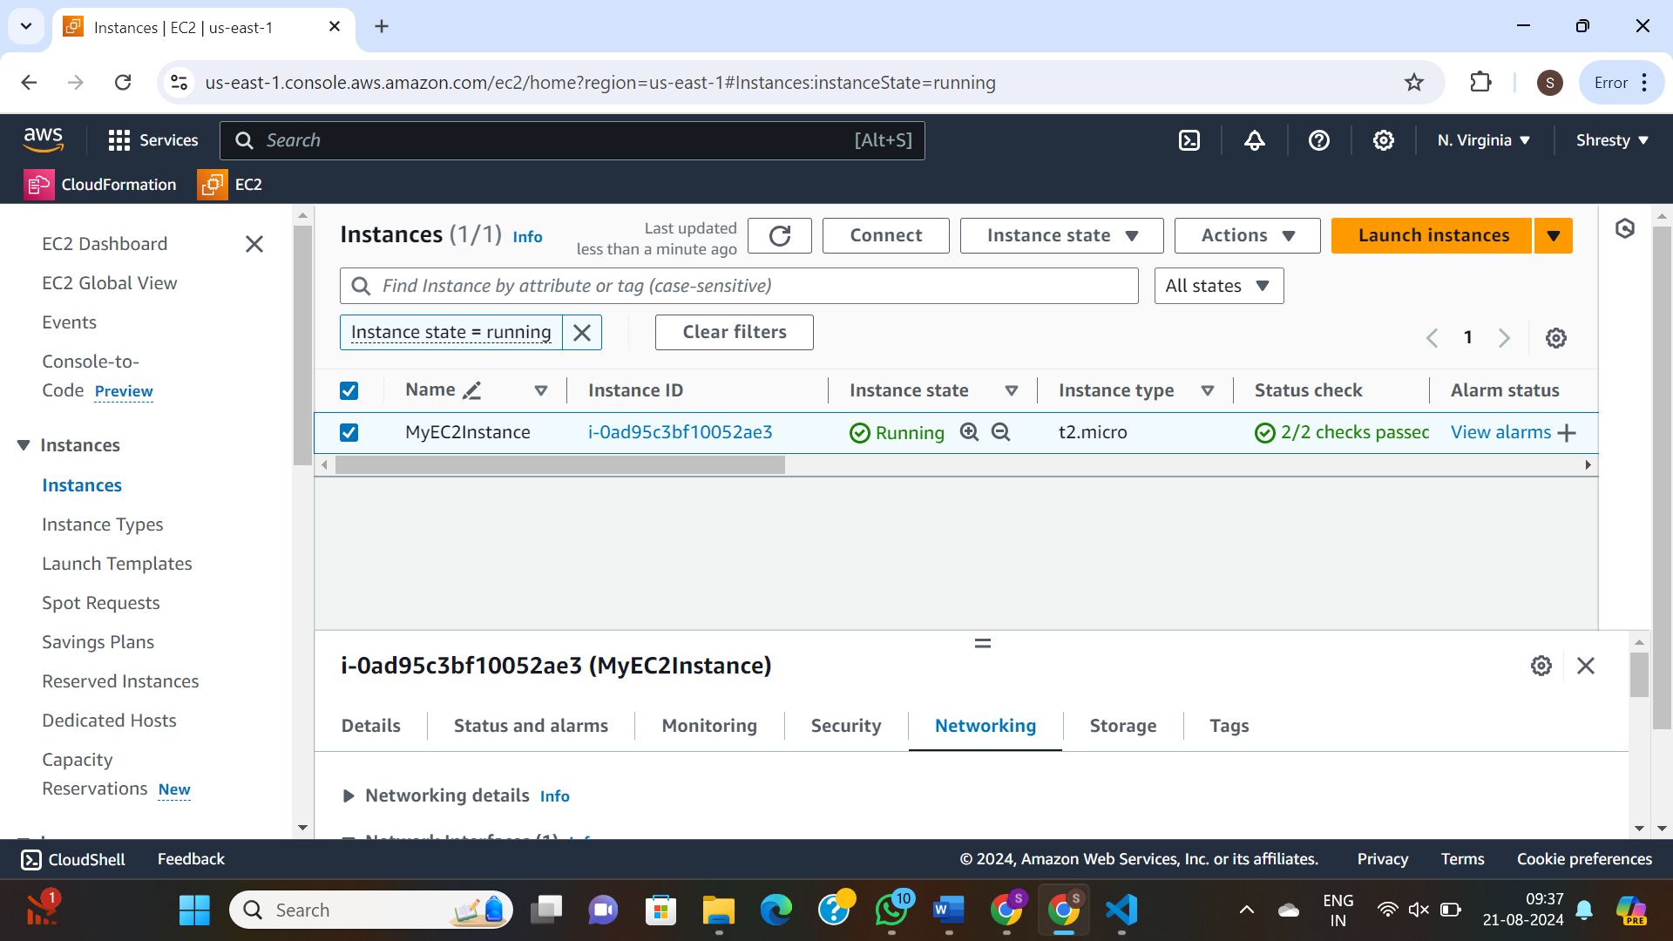

LAB3

We are going to create a simple CloudFormation template and provision a new EC2 instance. Also let's add conditionally provisioned EBS volume which must be created and attached to instance only if environment is 'prod'.

Description: >-

AWS CloudFormation sample template.

Create a new EC2 instance and if environment is 'prod' then attach a new EBS volume to it

## =================== PARAMETERS ===================

Parameters:

paramEnvironmentType: # ask a user to define whether it is 'dev', 'qa' or 'prod' environment

Description: Environment type

Default: dev # by default it is 'dev' environment

Type: String

AllowedValues: [dev, qa, prod]

ConstraintDescription: Must specify 'dev', 'qa' or 'prod'

paramTagValues: #ask a user to specify some values for tags

Description: 'Comma-delimited list of tag values'

Type: CommaDelimitedList

Default: 'JonSnow, DaenerysTargaryen, AryaStark'

## =================== MAPPINGS ===================

Mappings: # map image ids with regions

mapRegion:

us-east-1:

AMI: ami-1853ac65

us-west-1:

AMI: ami-bf5540df

eu-west-1:

AMI: ami-3bfab942

ap-southeast-1:

AMI: ami-e2adf99e

ap-southeast-2:

AMI: ami-43874721

## =================== CONDITIONS ===================

Conditions:

isProd: !Equals [!Ref paramEnvironmentType, prod] # if 'prod' then TRUE, otherwise FALSE

isDev: !Equals [!Ref paramEnvironmentType, dev] # if 'dev' then TRUE, otherwise FALSE

## =================== RESOURCES ===================

Resources:

myEC2Instance: # create a new EC2 instance

Type: 'AWS::EC2::Instance'

Properties:

ImageId: !FindInMap # define imageId based on region

- mapRegion # map's name

- !Ref 'AWS::Region' # top level key which is a region where a new instance is being created

- AMI # second level key - e.g. for 'us-east-1' the value for ImageId is 'ami-0ff8a91507f77f867'

InstanceType: !If [isProd, t2.micro, !If [isDev, t2.nano, t1.micro] ] # if 'prod', then t2.micro, (else) if 'dev' then t2.nano otherwise (if 'qa') then t1.micro

Tags:

- Key: CloudFormationLab

Value: !Join [' ', ['EC2 Instance for', !Ref AWS::Region] ]

myVolume: # create a new EBS volume only if environment is 'prod'

Type: 'AWS::EC2::Volume'

Condition: isProd # conditionally create EBS volume (only if environment is 'prod')

Properties:

Size: 100 # 100 GiB

AvailabilityZone: !GetAtt myEC2Instance.AvailabilityZone # get AZ of a new EC2 instance

Tags:

- Key: CloudFormationLab

Value: !Select [ 0, !Ref paramTagValues ] # output is 'JonSnow'

myMountPoint: # attach an Amazon EBS volume to an EC2 instance only i environment is 'prod'

Type: 'AWS::EC2::VolumeAttachment'

Condition: isProd # conditionally attach EBS volume (only if environment is 'prod')

Properties:

InstanceId: !Ref myEC2Instance # ref to a new EC2 instance

VolumeId: !Ref myVolume # ref to a new EBS volume

Device: /dev/sdh

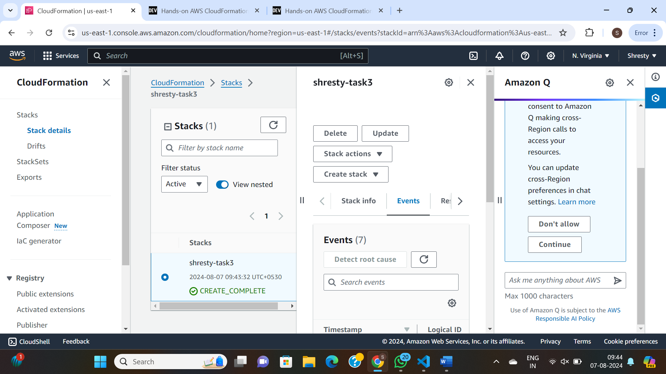

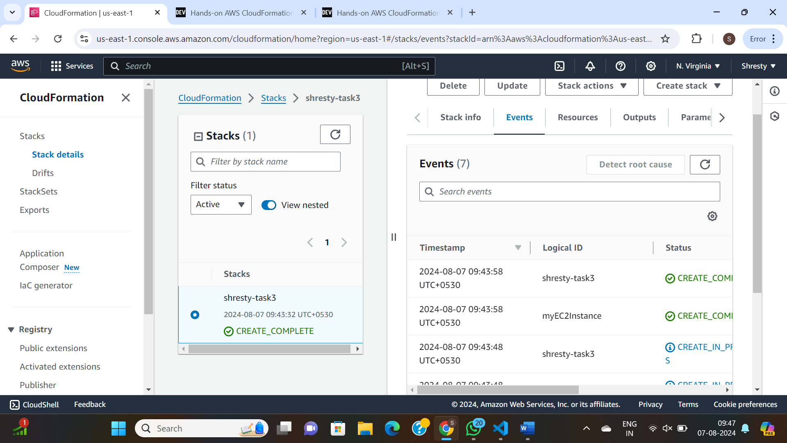

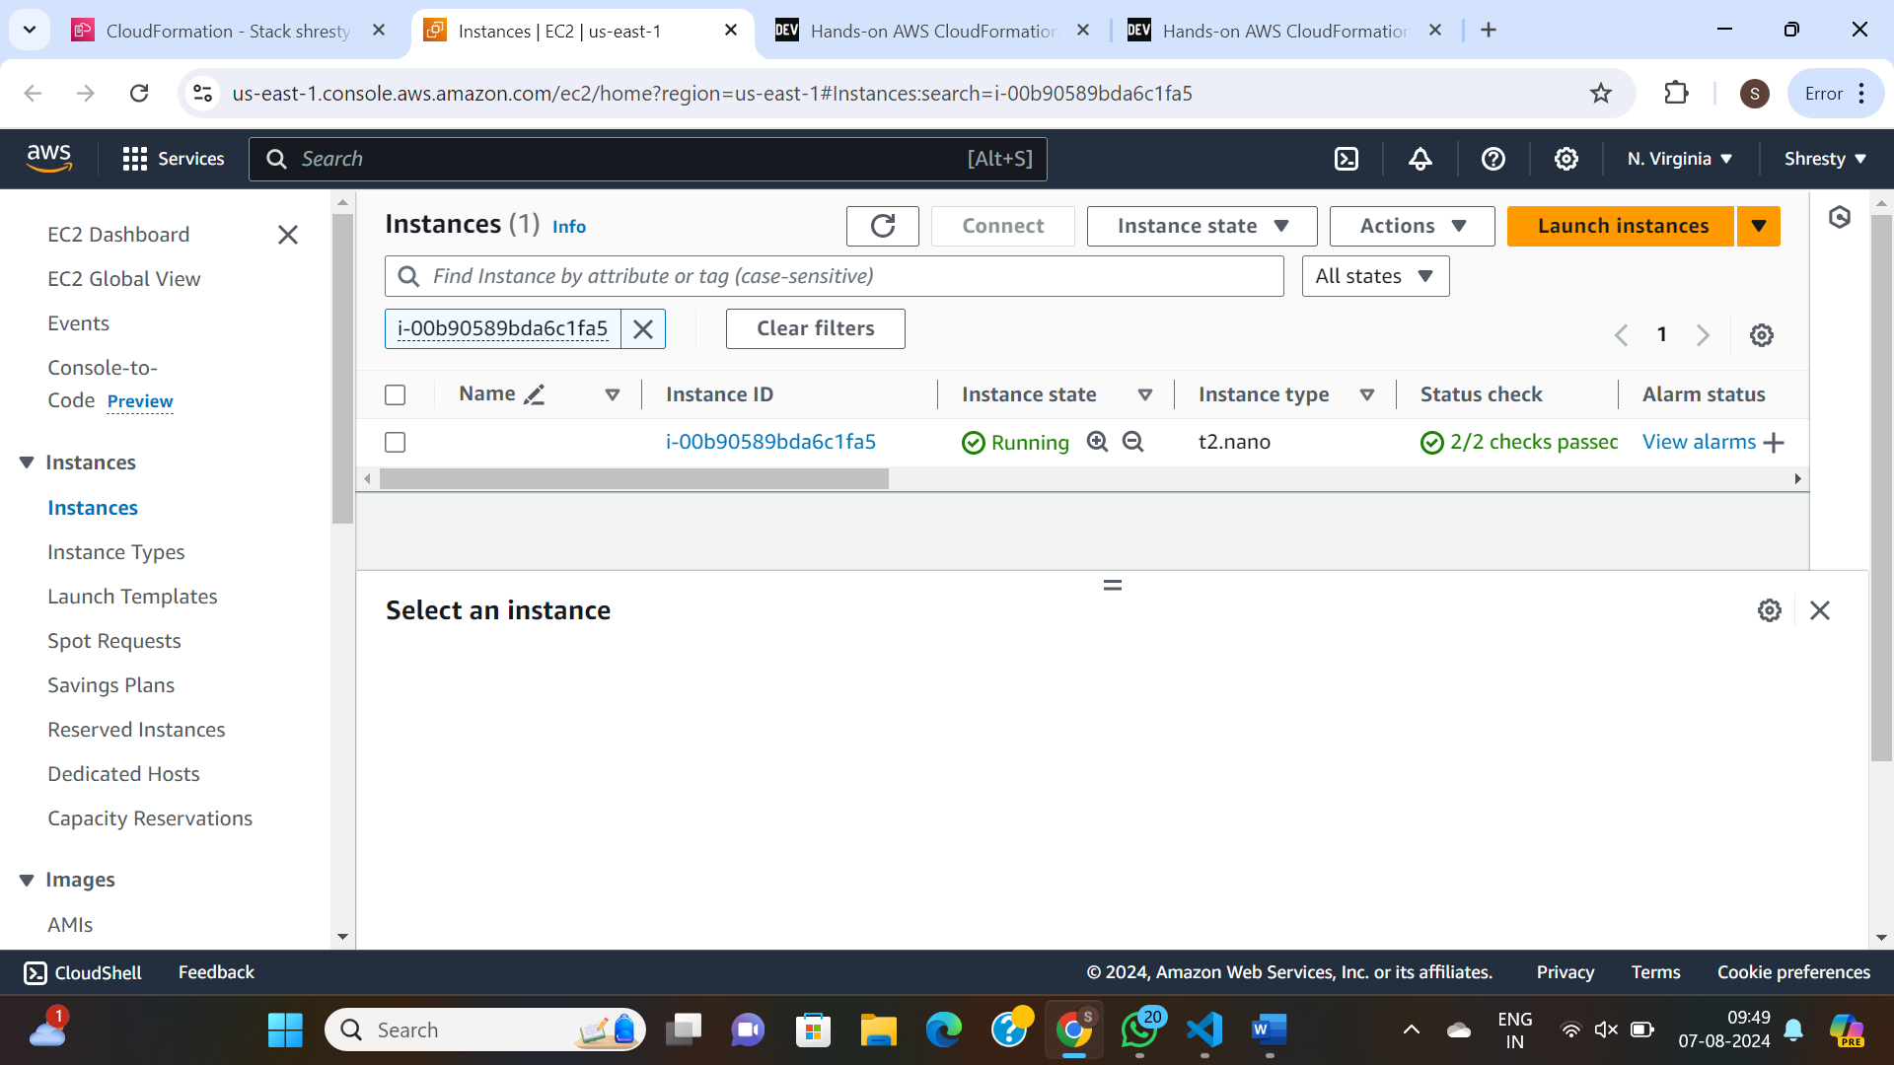

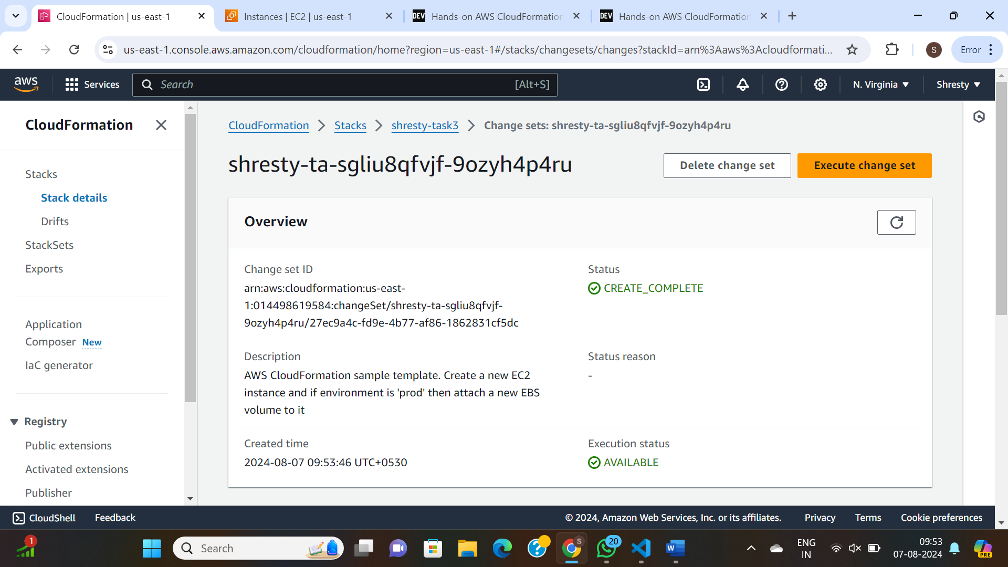

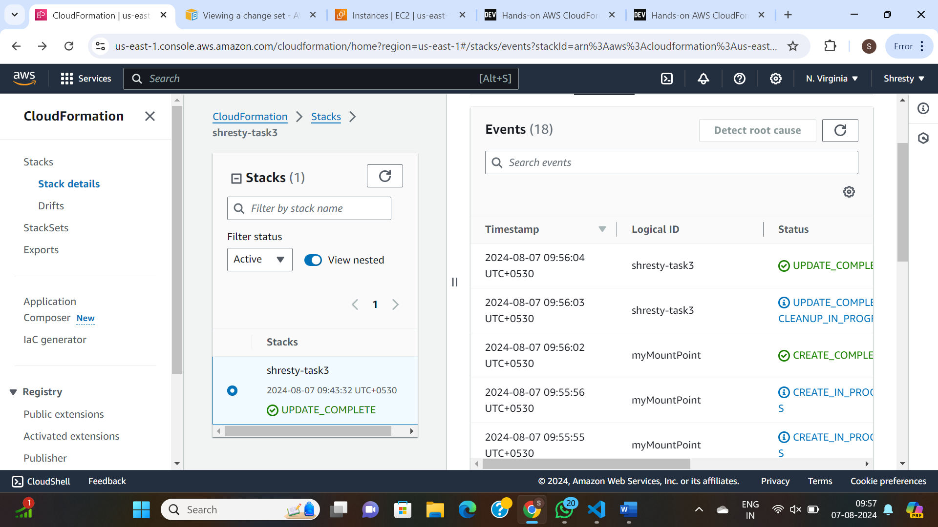

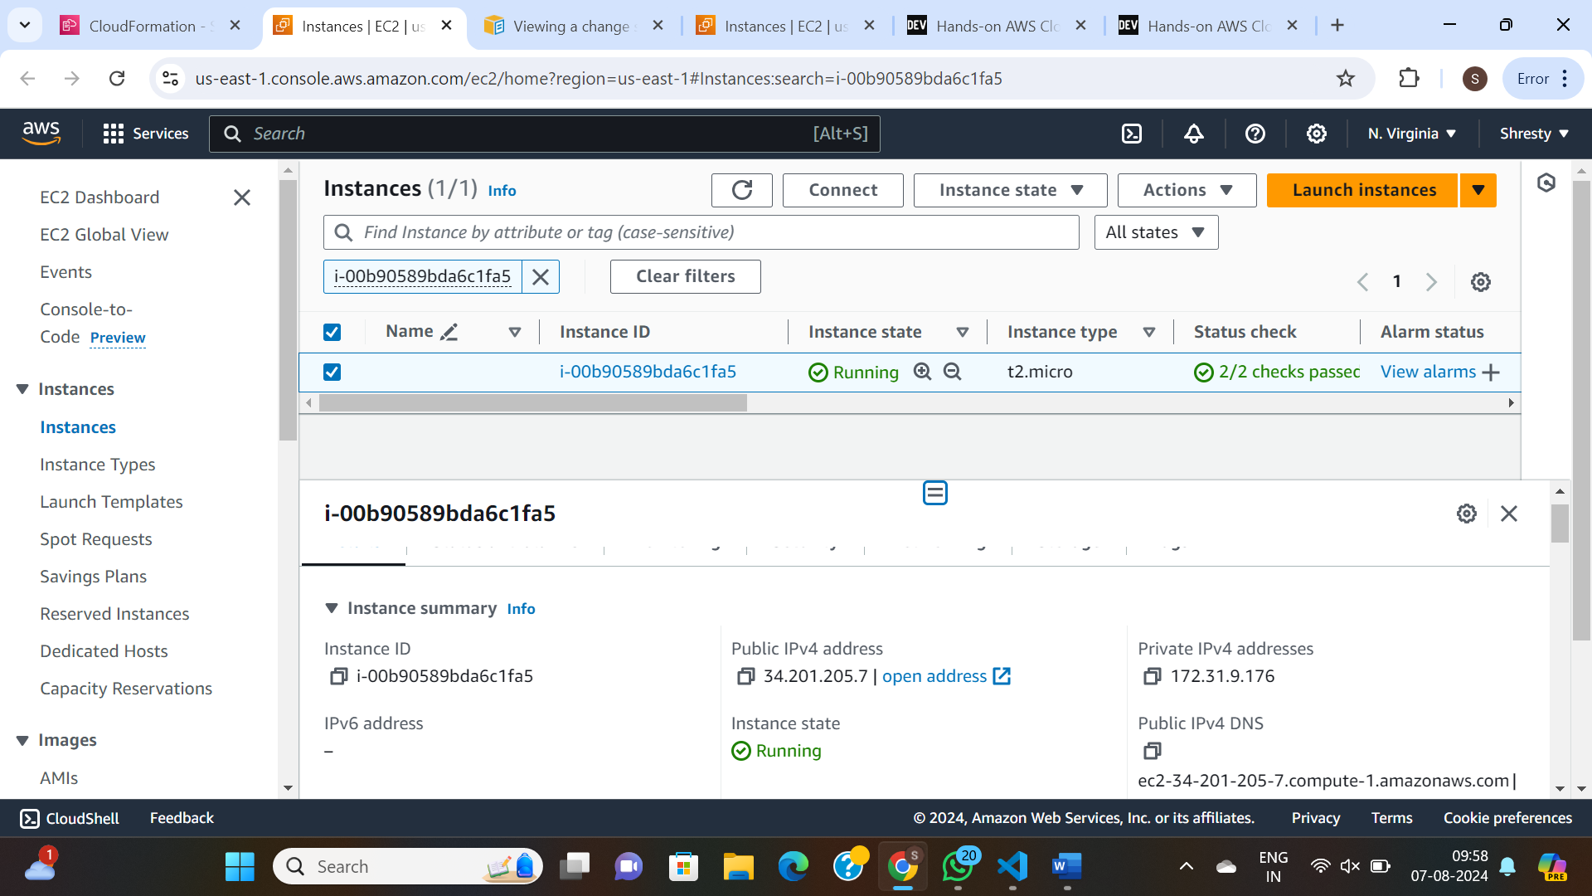

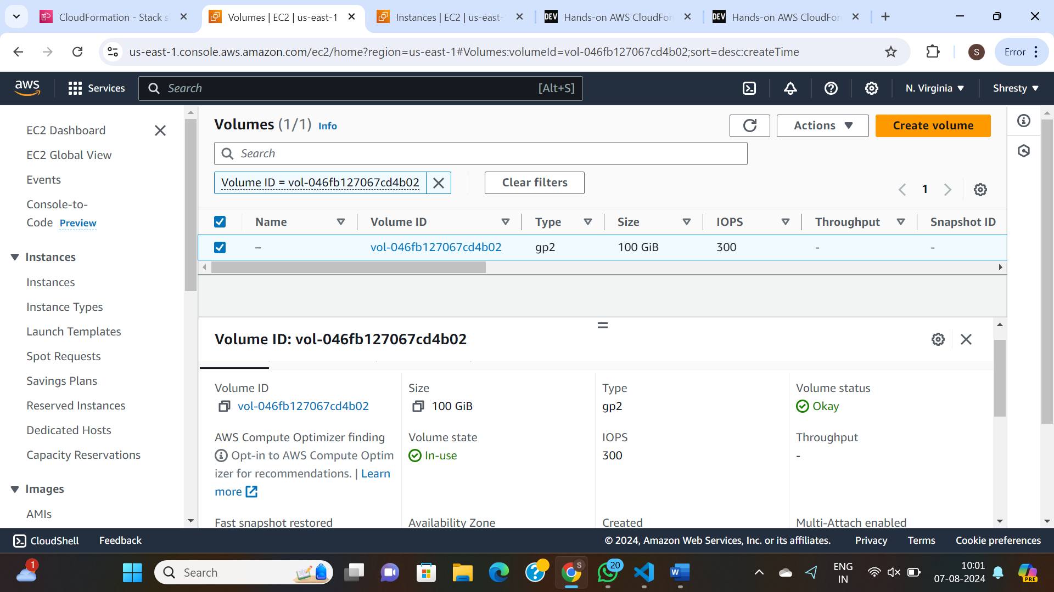

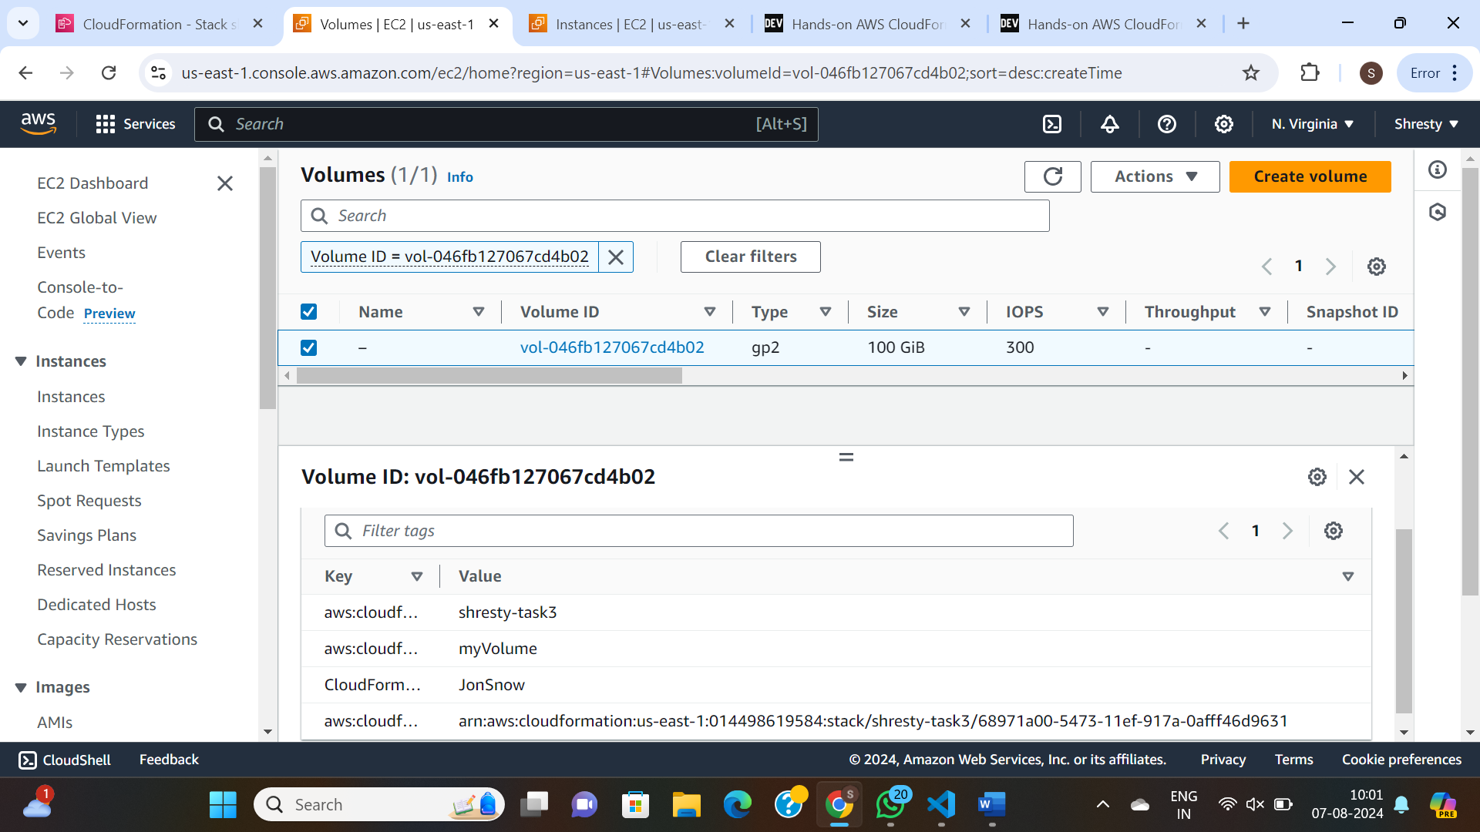

TASK-2

Here are core components that we are going to create:

* a VPC
* an Internet Gateway
* a custom route table for all public subnets
* two public subnets spread across two AZs
* two NAT Gateways attached to public subnets
* two custom route tables for each of private subnets
* two private subnets spread across two AZs

Parameters:

paramVpcCIDR:

Description: Enter the IP range (CIDR notation) for VPC

Type: String

Default: 10.192.0.0/16

paramUniqueName:

Description: Unique name for tagging

Type: String

Default: MyUniqueName

paramPublicSubnet1CIDR:

Description: Enter the IP range (CIDR notation) for the public subnet in AZ A

Type: String

Default: 10.192.10.0/24

paramPublicSubnet2CIDR:

Description: Enter the IP range (CIDR notation) for the public subnet in AZ B

Type: String

Default: 10.192.11.0/24

paramPrivateSubnet1CIDR:

Description: Enter the IP range (CIDR notation) for the private subnet in AZ A

Type: String

Default: 10.192.20.0/24

paramPrivateSubnet2CIDR:

Description: Enter the IP range (CIDR notation) for the private subnet in AZ B

Type: String

Default: 10.192.21.0/24

Resources:

myVPC:

Type: AWS::EC2::VPC

Properties:

CidrBlock: !Ref paramVpcCIDR

EnableDnsSupport: true

EnableDnsHostnames: true

Tags:

- Key: CloudFormationLab

Value: !Ref paramUniqueName

myInternetGateway:

Type: AWS::EC2::InternetGateway

Properties:

Tags:

- Key: CloudFormationLab

Value: !Ref paramUniqueName

myVPCGatewayAttachment:

Type: AWS::EC2::VPCGatewayAttachment

Properties:

VpcId: !Ref myVPC

InternetGatewayId: !Ref myInternetGateway

myPublicRouteTable:

Type: AWS::EC2::RouteTable

Properties:

VpcId: !Ref myVPC

Tags:

- Key: Name

Value: !Ref paramUniqueName

myPublicRoute:

Type: AWS::EC2::Route

DependsOn: myVPCGatewayAttachment

Properties:

RouteTableId: !Ref myPublicRouteTable

DestinationCidrBlock: 0.0.0.0/0

GatewayId: !Ref myInternetGateway

myPublicSubnet1:

Type: AWS::EC2::Subnet

Properties:

VpcId: !Ref myVPC

AvailabilityZone: !Select [ 0, !GetAZs '' ] # AZ 1

CidrBlock: !Ref paramPublicSubnet1CIDR

MapPublicIpOnLaunch: true

Tags:

- Key: Name

Value: !Ref paramUniqueName

myPublicSubnet2:

Type: AWS::EC2::Subnet

Properties:

VpcId: !Ref myVPC

AvailabilityZone: !Select [ 1, !GetAZs '' ] # AZ 2

CidrBlock: !Ref paramPublicSubnet2CIDR

MapPublicIpOnLaunch: true

Tags:

- Key: Name

Value: !Ref paramUniqueName

myPublicSubnet1RouteTableAssociation:

Type: AWS::EC2::SubnetRouteTableAssociation

Properties:

RouteTableId: !Ref myPublicRouteTable

SubnetId: !Ref myPublicSubnet1

myPublicSubnet2RouteTableAssociation:

Type: AWS::EC2::SubnetRouteTableAssociation

Properties:

RouteTableId: !Ref myPublicRouteTable

SubnetId: !Ref myPublicSubnet2

myEIPforNatGateway1:

Type: AWS::EC2::EIP

DependsOn: myVPCGatewayAttachment

Properties:

Domain: vpc

myEIPforNatGateway2:

Type: AWS::EC2::EIP

DependsOn: myVPCGatewayAttachment

Properties:

Domain: vpc

myNatGateway1:

Type: AWS::EC2::NatGateway

Properties:

AllocationId: !GetAtt myEIPforNatGateway1.AllocationId

SubnetId: !Ref myPublicSubnet1

myNatGateway2:

Type: AWS::EC2::NatGateway

Properties:

AllocationId: !GetAtt myEIPforNatGateway2.AllocationId

SubnetId: !Ref myPublicSubnet2

myPrivateRouteTable1:

Type: AWS::EC2::RouteTable

Properties:

VpcId: !Ref myVPC

Tags:

- Key: Name

Value: !Ref paramUniqueName

myPrivateRouteTable2:

Type: AWS::EC2::RouteTable

Properties:

VpcId: !Ref myVPC

Tags:

- Key: Name

Value: !Ref paramUniqueName

myPrivateRouteForAz1:

Type: AWS::EC2::Route

DependsOn: myVPCGatewayAttachment

Properties:

RouteTableId: !Ref myPrivateRouteTable1

DestinationCidrBlock: 0.0.0.0/0

NatGatewayId: !Ref myNatGateway1

myPrivateRouteForAz2:

Type: AWS::EC2::Route

DependsOn: myVPCGatewayAttachment

Properties:

RouteTableId: !Ref myPrivateRouteTable2

DestinationCidrBlock: 0.0.0.0/0

NatGatewayId: !Ref myNatGateway2

myPrivateSubnet1:

Type: AWS::EC2::Subnet

Properties:

VpcId: !Ref myVPC

AvailabilityZone: !Select [ 0, !GetAZs '' ] # AZ 1

CidrBlock: !Ref paramPrivateSubnet1CIDR

MapPublicIpOnLaunch: true

Tags:

- Key: Name

Value: !Ref paramUniqueName

myPrivateSubnet2:

Type: AWS::EC2::Subnet

Properties:

VpcId: !Ref myVPC

AvailabilityZone: !Select [ 1, !GetAZs '' ] # AZ 2

CidrBlock: !Ref paramPrivateSubnet2CIDR

MapPublicIpOnLaunch: true

Tags:

- Key: Name

Value: !Ref paramUniqueName

myPrivateSubnet1RouteTableAssociation:

Type: AWS::EC2::SubnetRouteTableAssociation

Properties:

RouteTableId: !Ref myPrivateRouteTable1

SubnetId: !Ref myPrivateSubnet1

myPrivateSubnet2RouteTableAssociation:

Type: AWS::EC2::SubnetRouteTableAssociation

Properties:

RouteTableId: !Ref myPrivateRouteTable2

SubnetId: !Ref myPrivateSubnet2

Outputs:

outputVPC:

Description: A reference to the created VPC

Value: !Ref myVPC

outputPublicSubnets:

Description: A list of the public subnets

Value: !Join [ ",", [ !Ref myPublicSubnet1, !Ref myPublicSubnet2 ]]

outputPrivateSubnets:

Description: A list of the private subnets

Value: !Join [ ",", [ !Ref myPrivateSubnet1, !Ref myPrivateSubnet2 ]]

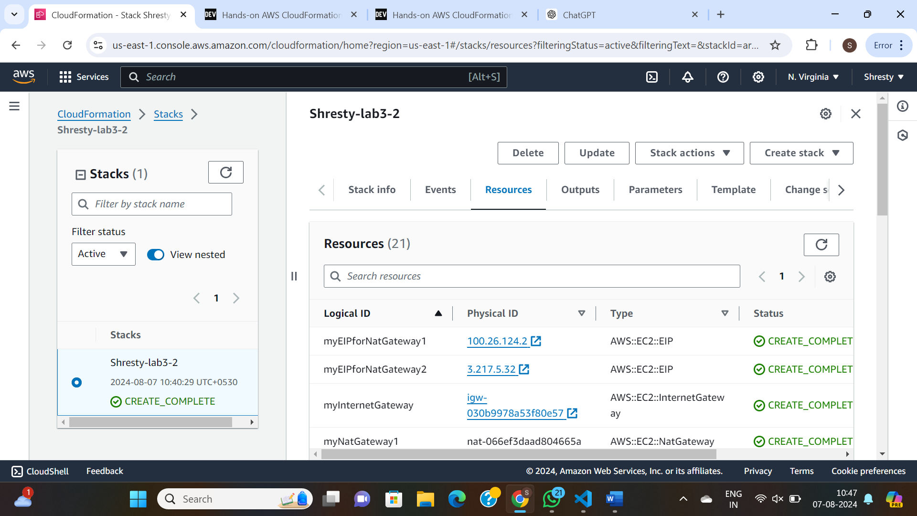

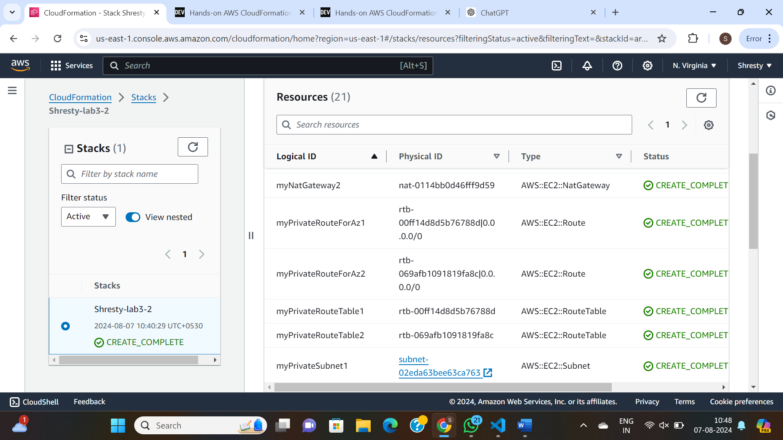

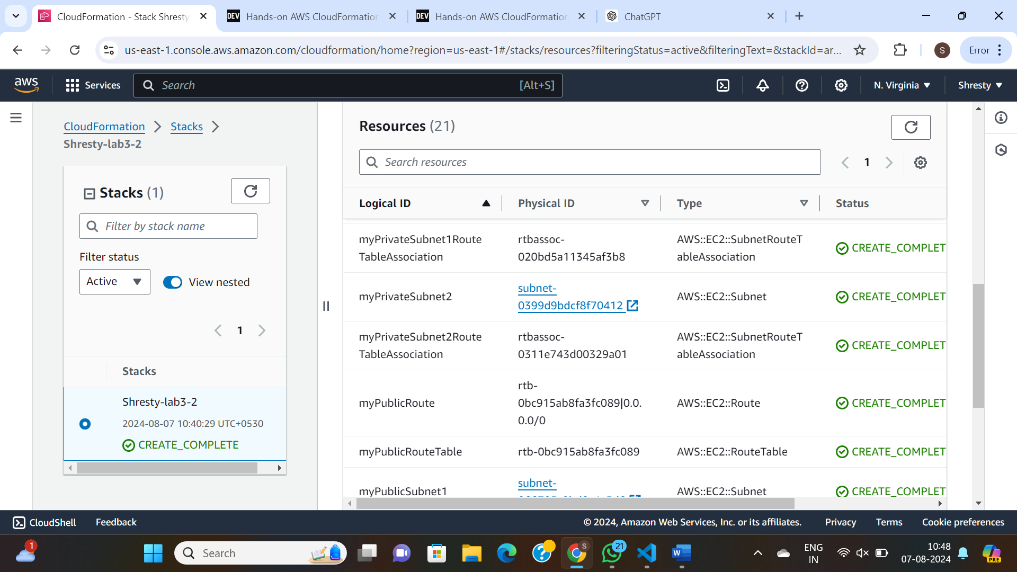

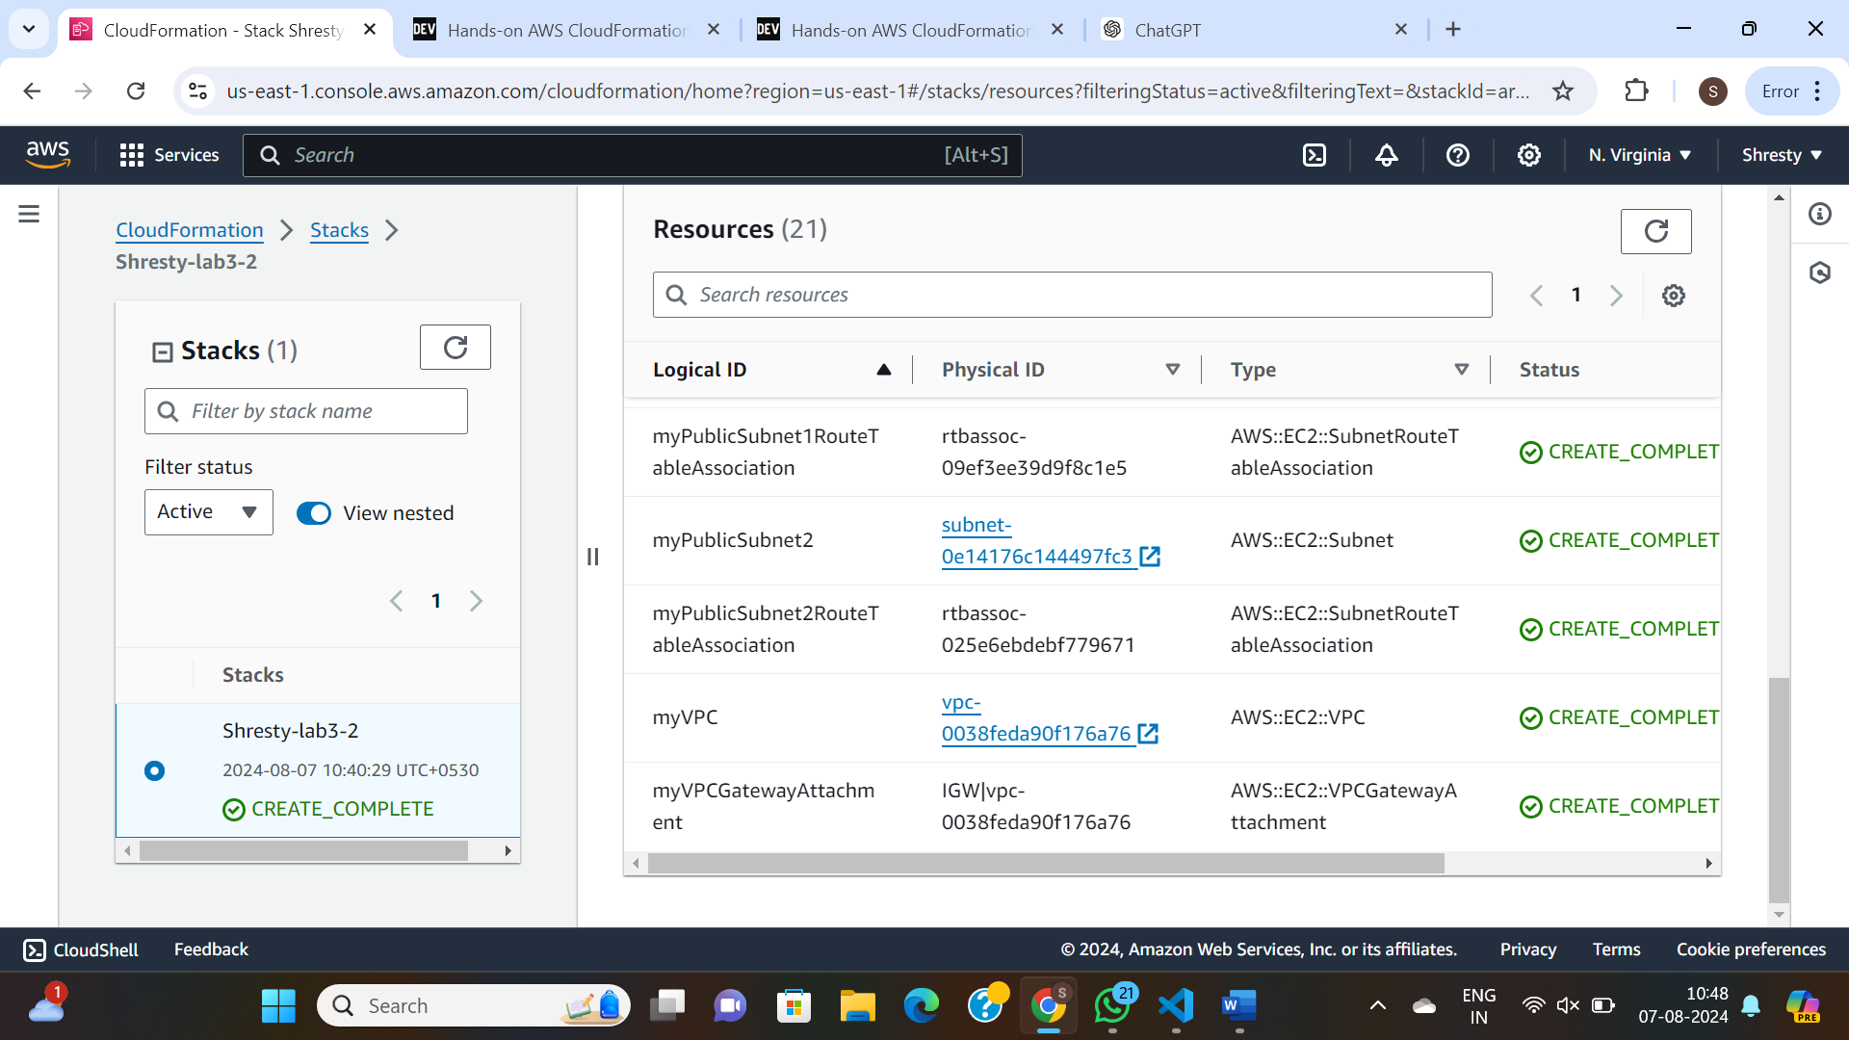

**TASK 3:**

Parameters:

InstanceType:

Description: 'EC2 instance type'

Type: String

Default: 't2.micro'

AllowedValues:

- t2.micro

- t2.small

- t2.medium

ConstraintDescription: 'Must be a valid EC2 instance type.'

KeyName:

Description: 'The name of the key pair to allow SSH access to the EC2 instance'

Type: AWS::EC2::KeyPair::KeyName

ConstraintDescription: 'Must be the name of an existing EC2 KeyPair.'

TagValue:

Description: 'Value for the Name tag of the EC2 instance'

Type: String

Default: 'shrestyEC2'

Mappings:

RegionMap:

us-east-1:

AMI: 'ami-066784287e358dad1'

Resources:

shrestyEC2:

Type: 'AWS::EC2::Instance'

Properties:

InstanceType: !Ref InstanceType

# KeyName: !Ref KeyName

ImageId: !FindInMap [RegionMap, !Ref 'AWS::Region', AMI]

Tags:

- Key: 'Name'

Value: !Ref TagValue

Outputs:

InstanceId:

Description: 'Instance ID of the newly created EC2 instance'

Value: !Ref shrestyEC2

AvailabilityZone:

Description: 'Availability Zone of the newly created EC2 instance'

Value: !GetAtt shrestyEC2.AvailabilityZone

PublicDnsName:

Description: 'Public DNS name of the newly created EC2 instance'

Value: !GetAtt shrestyEC2.PublicDnsName

PublicIp:

Description: 'Public IP address of the EC2 instance'

Value: !GetAtt shrestyEC2.PublicIp

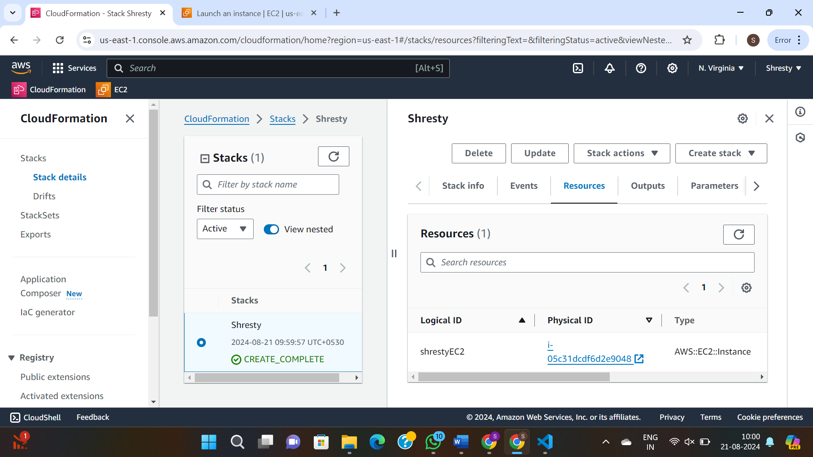

LAB 4:



**Lab Work -5**

**Overview**

**What is GitHub Actions:**

**GitHub Actions** is a powerful CI/CD (Continuous Integration and Continuous Deployment) platform that allows developers to automate, customize, and execute their software development workflows directly within GitHub. It integrates seamlessly with GitHub repositories, enabling developers to build, test, and deploy their code automatically whenever a new change is pushed.

**Key Features:**

1. **Automation**: GitHub Actions allows for automation of tasks such as building and testing code, deploying applications, and managing workflows. It supports custom workflows that can be triggered by events like pull requests, commits, or issues.
2. **Workflows**: A workflow is a configurable automated process made up of one or more jobs that can be triggered by events. Workflows are defined using YAML files, typically located in the .github/workflows/ directory of a repository.
3. **Jobs and Steps**:
   * **Jobs**: These are units of work executed by GitHub Actions. Jobs can run in parallel, and each job consists of multiple steps.
   * **Steps**: A step is a single task that can run a script, command, or action. Steps are executed sequentially within a job.
4. **Actions**: Actions are reusable units of code that perform a specific task. GitHub provides a marketplace where developers can find and use pre-built actions, or they can create their own custom actions.
5. **Runners**: A runner is a server that runs workflows. GitHub Actions provides both GitHub-hosted runners (on Ubuntu, Windows, and macOS) and self-hosted runners, which allow for more control over the environment in which workflows are executed.

**Hands-on:**

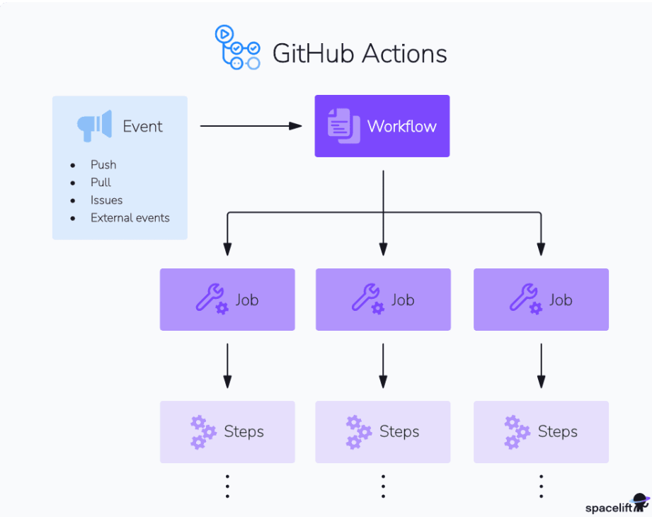

**Code.py**

from http.server import BaseHTTPRequestHandler, HTTPServer

import urllib.parse as urlparse

def add(a, b):

print”Shresty”

return a + b

class AdditionHandler(BaseHTTPRequestHandler):

def do_GET(self):

parsed_path = urlparse.urlparse(self.path)

query_params = urlparse.parse_qs(parsed_path.query)

try:

a = int(query_params.get('a', [None])[0])

b = int(query_params.get('b', [None])[0])

if a is None or b is None:

raise ValueError("Parameters 'a' and 'b' must be provided")

result = add(a, b)

self.send_response(200)

self.send_header("Content-type", "text/html")

self.end_headers()

self.wfile.write(str(result).encode())

except (ValueError, TypeError):

self.send_response(400)

self.send_header("Content-type", "text/html")

self.end_headers()

self.wfile.write(b"Parameters 'a' and 'b' must be integers")

def run(server_class=HTTPServer, handler_class=AdditionHandler, port=8080):

server_address = ('', port)

httpd = server_class(server_address, handler_class)

print(f"Server listening on port {port}...")

httpd.serve_forever()

if __name__ == '__main__':

run()

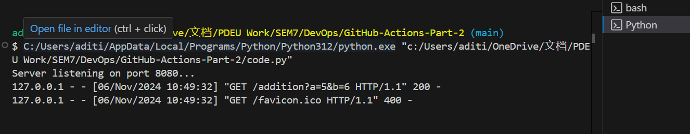

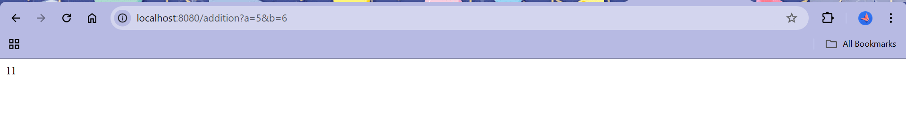

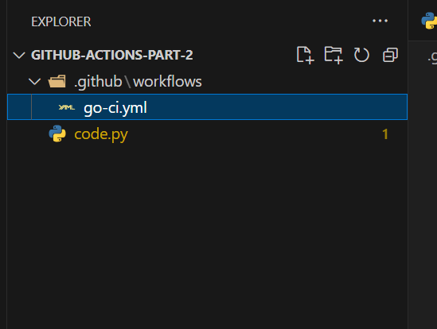

name: Go CI

on:

push:

branches:

- main

pull_request:

branches:

- main

jobs:

build:

runs-on: ubuntu-latest

steps:

# Check out the repository code

- name: Check out code

uses: actions/checkout@v3

# Set up Go

- name: Set up Go

uses: actions/setup-go@v4

with:

go-version: 1.20 # Use the version of Go you need

# Cache Go modules

- name: Cache Go modules

uses: actions/cache@v3

with:

path: ~/go/pkg/mod

key: ${{ runner.os }}-go-${{ hashFiles('**/go.sum') }}

restore-keys: |

${{ runner.os }}-go-

# Install dependencies

- name: Install dependencies

run: go mod download

# Run tests

- name: Run tests

run: go test ./...

# Build the application

- name: Build

run: go build -o addition-app

# Run server tests if needed

- name: Run server test

run: |

go test -v -run "^TestAdditionHandler$"

